 | The Badge    Towns County Sheriff’s Office News | August 2025  Issue Thirty Seven
From the desk of Sheriff Ken Henderson:
August means BACK TO SCHOOL!
Towns County students have gone back to school this month and are in full swing for the year! Many different sports programs are starting back and keeping kids busy already. I look forward to seeing many of you out at the games supporting our students.


I want to mention again, that we should all be aware of phone, e-mail, text etc scammers. These scams are always an issue, and we want to remind you that the Sheriff’s Office will never call you and ask for money to take care of a warrant or for a loved one’s warrant. Please remember to never click a link in e-mail or text messages that you do not know where it came from and like the old saying goes, “If it seems too good to be true, it probably is.”
There is also more information about an IRS Scam in this issue of The Badge. Please share this information with loved ones and anyone that could benefit from it.
[Grab your reader’s attention with a great quote from the document or use this space to emphasize a key point. To place this text box anywhere on the page, just drag it.]

Towns County Sheriff’s Office Mission Statement
Our Mission is to modernize the Towns County Sheriff’s Office and to provide quality enforcement services using proactive enforcement, community partnership and problem solving, which will create a safe, secure, and desirable living and working environment for our citizens and visitors.
[Grab your reader’s attention with a great quote from the document or use this space to emphasize a key point. To place this text box anywhere on the page, just drag it.]

August DRUG ARRESTS
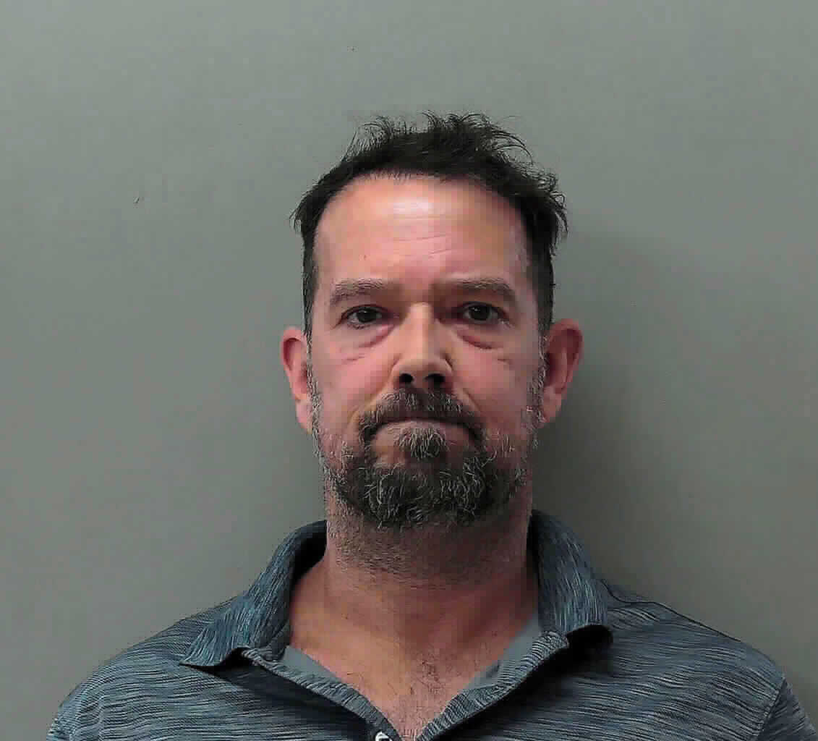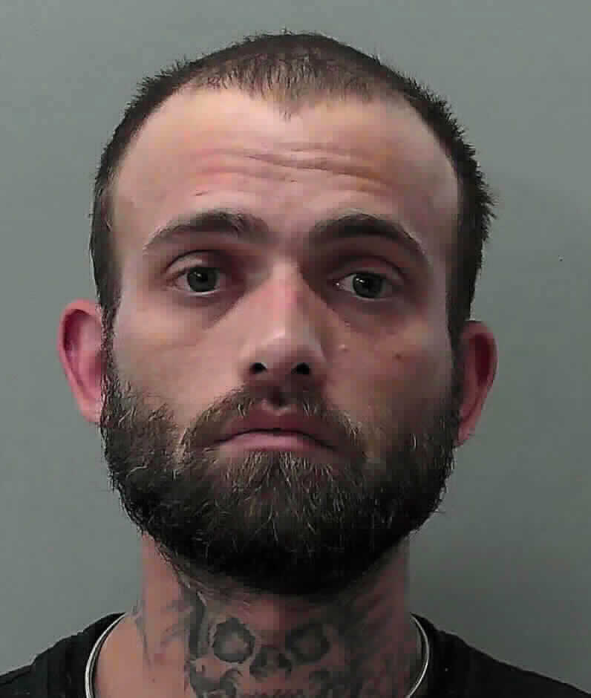

[Grab your reader’s attention with a great quote from the document or use this space to emphasize a key point. To place this text box anywhere on the page, just drag it.]

*All individuals are presumed innocent until proven guilty in a court of law*
[Grab your reader’s attention with a great quote from the document or use this space to emphasize a key point. To place this text box anywhere on the page, just drag it.]

GBI Investigates Inmate Death in Towns County

Hiawassee, GA (August 4, 2025) - At the request of the Towns County Sheriff’s Office, GBI agents are investigating the death of Brian William Whitney, age 44, of Hiawassee, GA, who was an inmate in the Towns County Jail.

On August 2, 2025, at about 3:05 a.m., Towns County deputies discovered Whitney unresponsive in his cell. Whitney was pronounced dead at the jail after EMS arrived. Preliminary information indicates that there was no foul play involved in Whitney’s death.
An autopsy will be conducted at the GBI Crime Lab.


Update: On the morning of 05/29/2025, the subject, Jason Garrett turned himself in at the Towns County Sheriffs Office.
The Towns County Sheriff's Office Drug Investigators conducted a month long investigation into an individual at a residence on Bugscuffle Rd.
On 05/21/2025, investigators obtained a search warrant for the residence. During the execution of the search an amount of meth which field tested positive was confiscated along with multiple types of pills. During the execution of the search of the residence, the 2 individuals that were the target of the drug investigation were not at the residence at the time.
Laurel Taylor Lambert, 40, of Hayesville NC, was arrested on 05/27/2025 on the warrants issued on 05/21/2025 and charged with:
• Felony, Possession of Methamphetamine
On 05/21/2025, arrest warrants were issued on Jason Levon Garrett, 51, of Hiawassee, for the following charges:
• Felony, Possession of Methamphetamine
• Felony, Possession of a controlled substance with intent to distribute
• Felony, Possession of a controlled substance X3
• Misdemeanor, Possession and Use of Drug Related Objects
Garrett is still at large on active warrants. Anyone with information of the subjects whereabouts should contact the Towns County Sheriff’s Office or call 911.
Sheriff Ken Henderson stated during the investigation, information was revealed that the suspect, Garrett, had been dealing drugs from his residence for at least 3 months. Sheriff Henderson commends the drug investigators and uniform patrol deputies for their hard work on a month long investigation into individuals who were selling drugs in our community. Our war on drugs continues.
**All subjects are presumed innocent until proven guilty in a court of law**

Newly Appointed Seargeant to TCSO Narcotics Division

More exciting PROMOTIONS at the Towns County Sheriff’s Office!!!
Sheriff Ken Henderson is proud to announce another well-deserved promotion within the agency.
Please join us in congratulating Keanu Nguyen as one of our new Sergeants.
Sergeant Nguyen will continue his ￼dedication, professionalism and commitment within our Narcotics Division as well as to the citizens of Towns County in his newly appointed position.
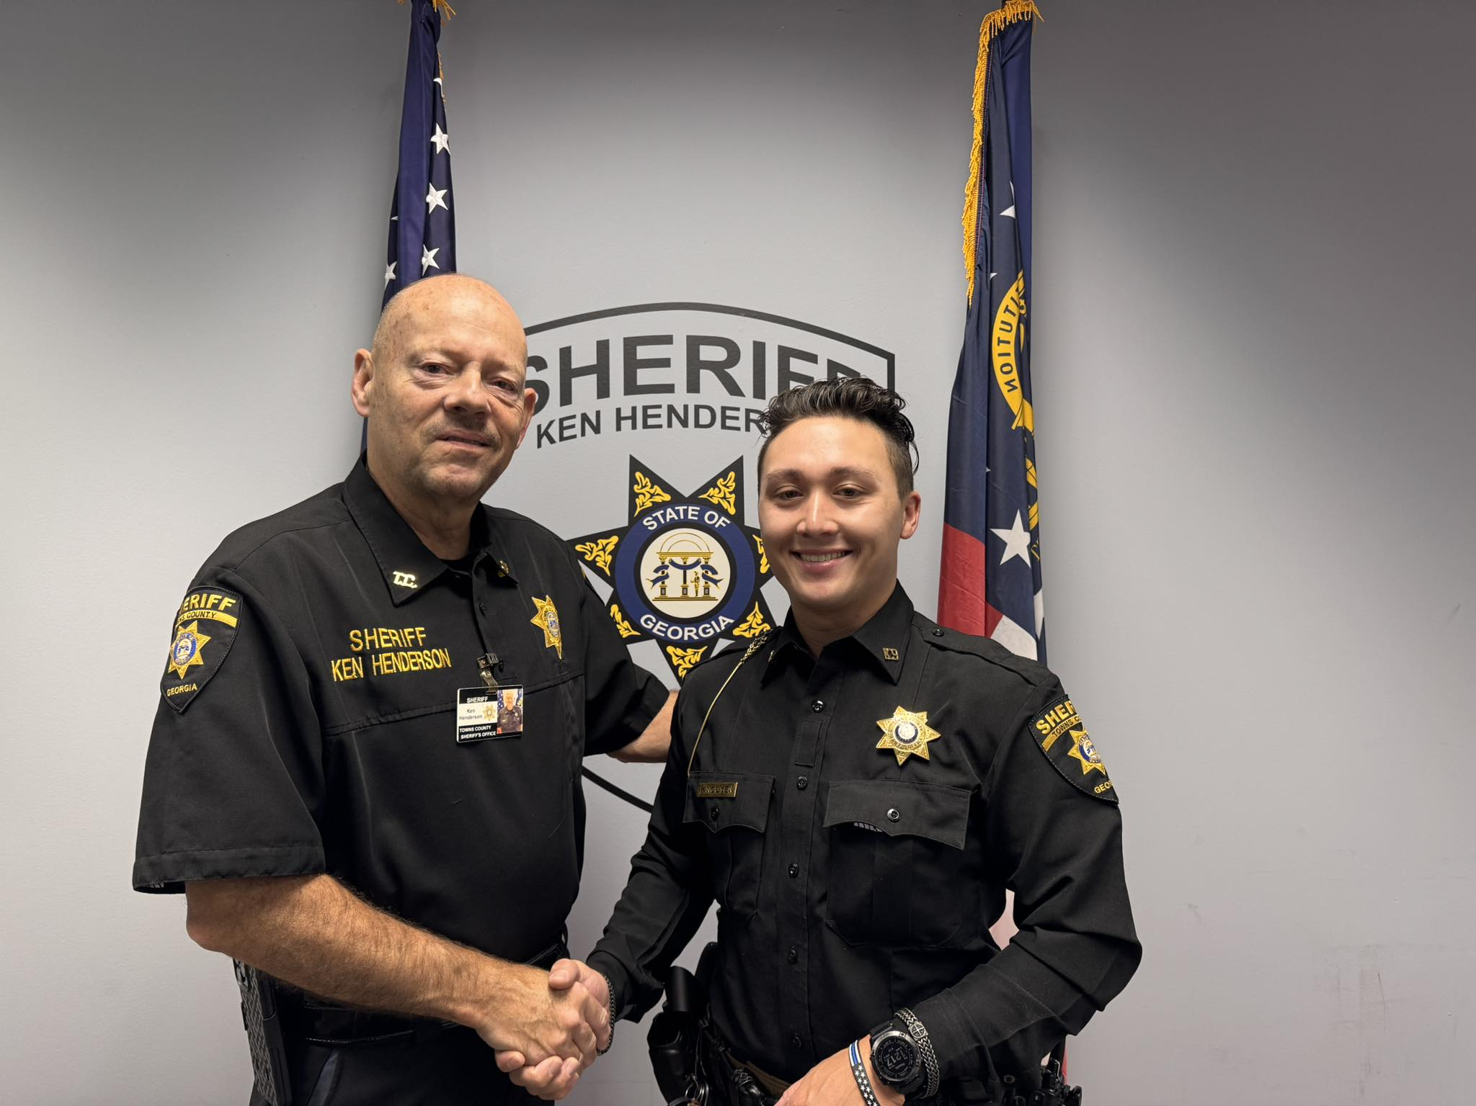

Update: On the morning of 05/29/2025, the subject, Jason Garrett turned himself in at the Towns County Sheriffs Office.
The Towns County Sheriff's Office Drug Investigators conducted a month long investigation into an individual at a residence on Bugscuffle Rd.
On 05/21/2025, investigators obtained a search warrant for the residence. During the execution of the search an amount of meth which field tested positive was confiscated along with multiple types of pills. During the execution of the search of the residence, the 2 individuals that were the target of the drug investigation were not at the residence at the time.
Laurel Taylor Lambert, 40, of Hayesville NC, was arrested on 05/27/2025 on the warrants issued on 05/21/2025 and charged with:
• Felony, Possession of Methamphetamine
On 05/21/2025, arrest warrants were issued on Jason Levon Garrett, 51, of Hiawassee, for the following charges:
• Felony, Possession of Methamphetamine
• Felony, Possession of a controlled substance with intent to distribute
• Felony, Possession of a controlled substance X3
• Misdemeanor, Possession and Use of Drug Related Objects
Garrett is still at large on active warrants. Anyone with information of the subjects whereabouts should contact the Towns County Sheriff’s Office or call 911.
Sheriff Ken Henderson stated during the investigation, information was revealed that the suspect, Garrett, had been dealing drugs from his residence for at least 3 months. Sheriff Henderson commends the drug investigators and uniform patrol deputies for their hard work on a month long investigation into individuals who were selling drugs in our community. Our war on drugs continues.
**All subjects are presumed innocent until proven guilty in a court of law**

Back to School--Bus Safety Tips

August is back-to-school safety month, and the Towns County Sheriff’s Office would like to provide our citizens with tips about sharing the road safely with school buses.

Never pass a bus from behind if it’s stopped to load or unload children.
If the yellow or red lights are flashing and the stop arm is extended, traffic must stop.
The area 10 feet around a school bus is the most dangerous for children; stop far enough back to allow them space to safely enter and exit the bus.
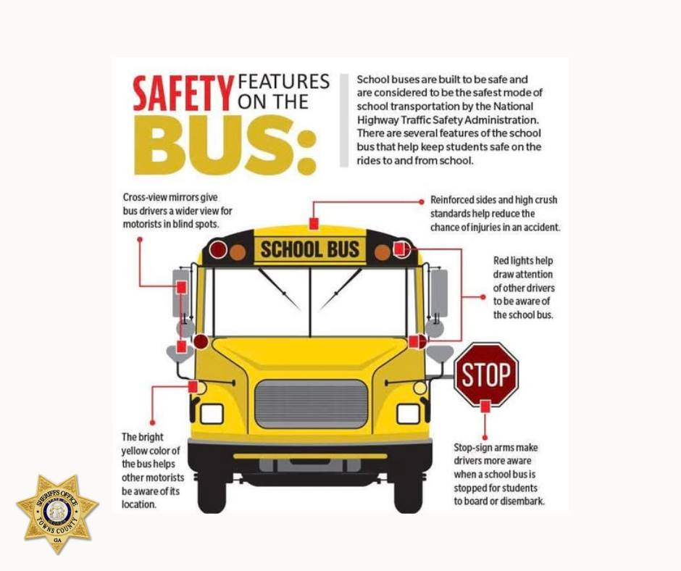
Months-Long Investigation Leads to Felony Drug Trafficking Charges

On Saturday evening 08/02/2025, after a month-long drug activity investigation into individuals, a traffic stop was made on HWY 17 and HWY 76 by the Towns County Sheriffs Drug Investigators and K-9, Dargo.
Probable cause was developed and a large amount of meth field tested positive and was confiscated, along with weapons.
As a result, Brandon Taylor and Kimberly Allison both from Hayesville were arrested.
Kimberly Jo Allison, 42, of Hayesville NC was arrested and charged with the following:
• Felony, Possession of Methamphetamine
• Felony, Possession of Methamphetamine with Intent to Distribute
• Felony, Trafficking In Cocaine, Illegal Drugs, Marijuana, or Methamphetamine
• Felony, Possession of Firearm or Knife During Commission Of or Attempt to Commit Certain Crimes
• Misdemeanor, Possession and Use of Drug Related Objects
James Brandon Taylor, 30, of Hayesville NC was arrested and charged with the following:
• Felony, Possession of Methamphetamine
• Felony, Possession of Methamphetamine with Intent to Distribute
• Felony, Trafficking In Cocaine, Illegal Drugs, Marijuana, or Methamphetamine
• Felony, Possession of Firearm or Knife During Commission of or Attempt to Commit Certain Crimes
• Felony, Receipt, Possession or Transport of Firearm By Convicted Felon or Felony First Offender
• Misdemeanor, Possession and Use of Drug Related Objects
Probable cause for a search of their Town Mountain Rd residence was presented to the Clay County Sheriff’s Office Drug Investigators. A search warrant was issued and a search of the residence by the Clay County Sheriff’s Office resulted in the confiscation of another large amount of methamphetamine along with weapons and drug paraphernalia.
Sheriff Henderson is proud to work together with other agencies to battle this war on removing drugs from our counties.

***All suspects are presumed innocent until proven guilty in a court of law***

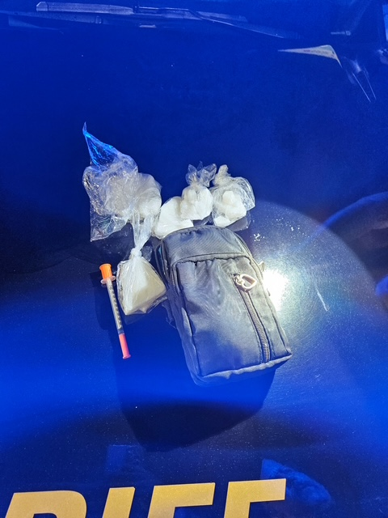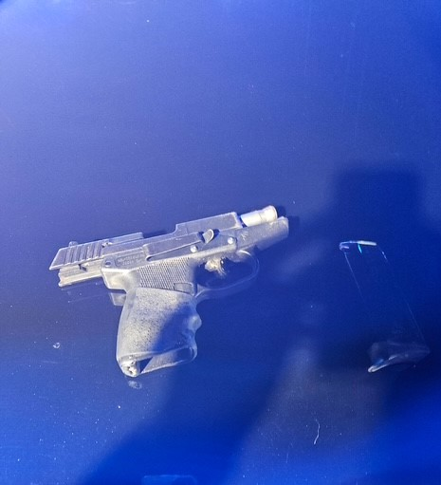
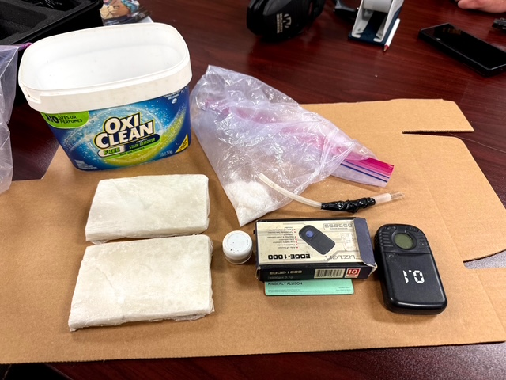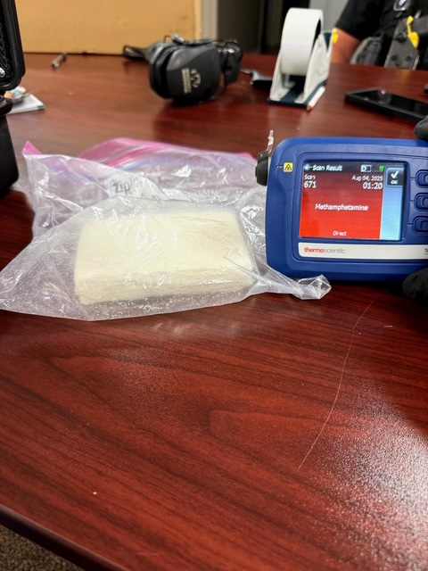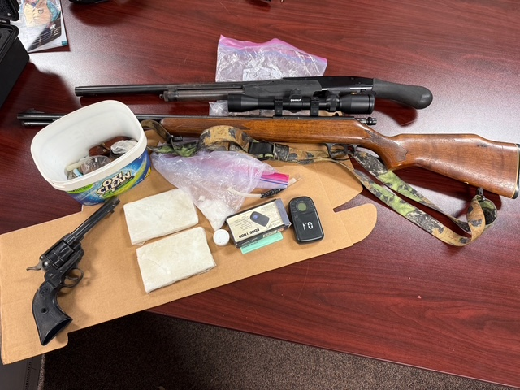
Sheriff Henderson Leads Surrounding Counties in Working Together

Towns County Sheriff Ken Henderson and Command Staff met with Union County Sheriff Shawn Dyer and Clay County Sheriff Mark Buchanan along with their respective Command Staffs for a luncheon to gather information about criminal and drug activity and to exchange ideas on how better to solve common problems.

Sheriff Henderson is excited to work with surrounding agencies and is appreciative of their commitment to working closely with our agency on these issues.
Together we are keeping our communities safe.

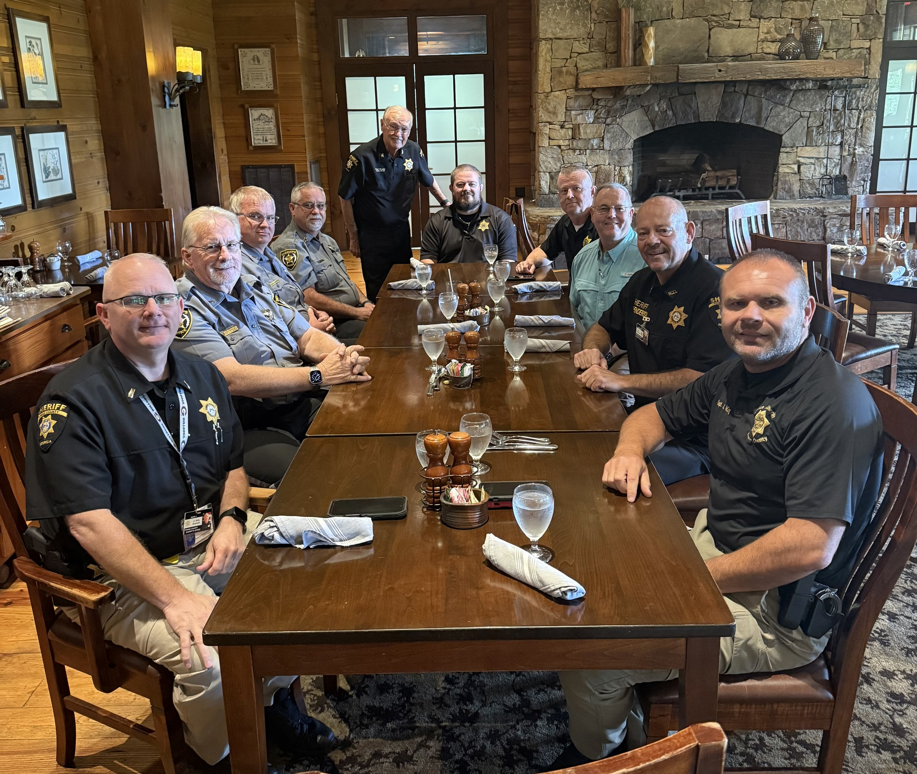

Update: On the morning of 05/29/2025, the subject, Jason Garrett turned himself in at the Towns County Sheriffs Office.
The Towns County Sheriff's Office Drug Investigators conducted a month long investigation into an individual at a residence on Bugscuffle Rd.
On 05/21/2025, investigators obtained a search warrant for the residence. During the execution of the search an amount of meth which field tested positive was confiscated along with multiple types of pills. During the execution of the search of the residence, the 2 individuals that were the target of the drug investigation were not at the residence at the time.
Laurel Taylor Lambert, 40, of Hayesville NC, was arrested on 05/27/2025 on the warrants issued on 05/21/2025 and charged with:
• Felony, Possession of Methamphetamine
On 05/21/2025, arrest warrants were issued on Jason Levon Garrett, 51, of Hiawassee, for the following charges:
• Felony, Possession of Methamphetamine
• Felony, Possession of a controlled substance with intent to distribute
• Felony, Possession of a controlled substance X3
• Misdemeanor, Possession and Use of Drug Related Objects
Garrett is still at large on active warrants. Anyone with information of the subjects whereabouts should contact the Towns County Sheriff’s Office or call 911.
Sheriff Ken Henderson stated during the investigation, information was revealed that the suspect, Garrett, had been dealing drugs from his residence for at least 3 months. Sheriff Henderson commends the drug investigators and uniform patrol deputies for their hard work on a month long investigation into individuals who were selling drugs in our community. Our war on drugs continues.
**All subjects are presumed innocent until proven guilty in a court of law**

Traffic Stop Leads to ICE Detainer
A recent traffic stop by Towns County Sheriff’s Office led to a detainer being placed by the United States Immigration and Customs Enforcement (ICE).
ICE picked up Carlos Jesus Bonilla-Moreno up on Thursday August 7, 2025, without incident.

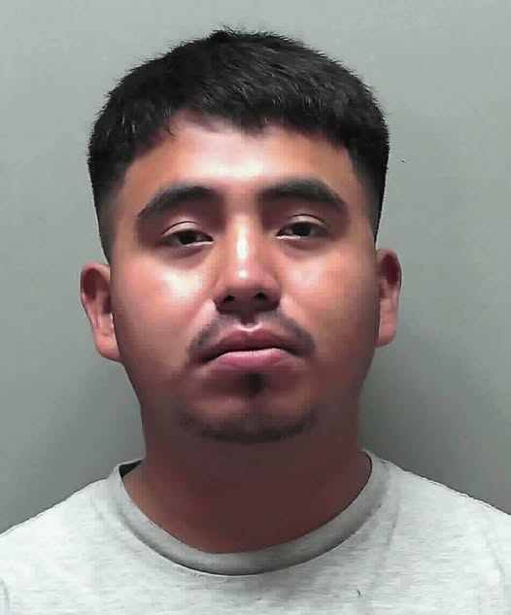
Update: On the morning of 05/29/2025, the subject, Jason Garrett turned himself in at the Towns County Sheriffs Office.
The Towns County Sheriff's Office Drug Investigators conducted a month long investigation into an individual at a residence on Bugscuffle Rd.
On 05/21/2025, investigators obtained a search warrant for the residence. During the execution of the search an amount of meth which field tested positive was confiscated along with multiple types of pills. During the execution of the search of the residence, the 2 individuals that were the target of the drug investigation were not at the residence at the time.
Laurel Taylor Lambert, 40, of Hayesville NC, was arrested on 05/27/2025 on the warrants issued on 05/21/2025 and charged with:
• Felony, Possession of Methamphetamine
On 05/21/2025, arrest warrants were issued on Jason Levon Garrett, 51, of Hiawassee, for the following charges:
• Felony, Possession of Methamphetamine
• Felony, Possession of a controlled substance with intent to distribute
• Felony, Possession of a controlled substance X3
• Misdemeanor, Possession and Use of Drug Related Objects
Garrett is still at large on active warrants. Anyone with information of the subjects whereabouts should contact the Towns County Sheriff’s Office or call 911.
Sheriff Ken Henderson stated during the investigation, information was revealed that the suspect, Garrett, had been dealing drugs from his residence for at least 3 months. Sheriff Henderson commends the drug investigators and uniform patrol deputies for their hard work on a month long investigation into individuals who were selling drugs in our community. Our war on drugs continues.
**All subjects are presumed innocent until proven guilty in a court of law**

DeKalb County PD Officer Killed In the Line of Duty

Sheriff Ken Henderson and his entire staff are extending our deepest condolences and prayers to Officer David Rose’s family, friends and fellow DeKalb County officers.
Officer David Rose served with the DeKalb County Police Department. He was a father with a growing family before a gunman opened fire and senselessly took his life near Emory University and the Centers for Disease Control and Prevention headquarters in Atlanta.

“The wicked flee when no one pursues, but the righteous are bold as a lion." - Proverbs 28:1

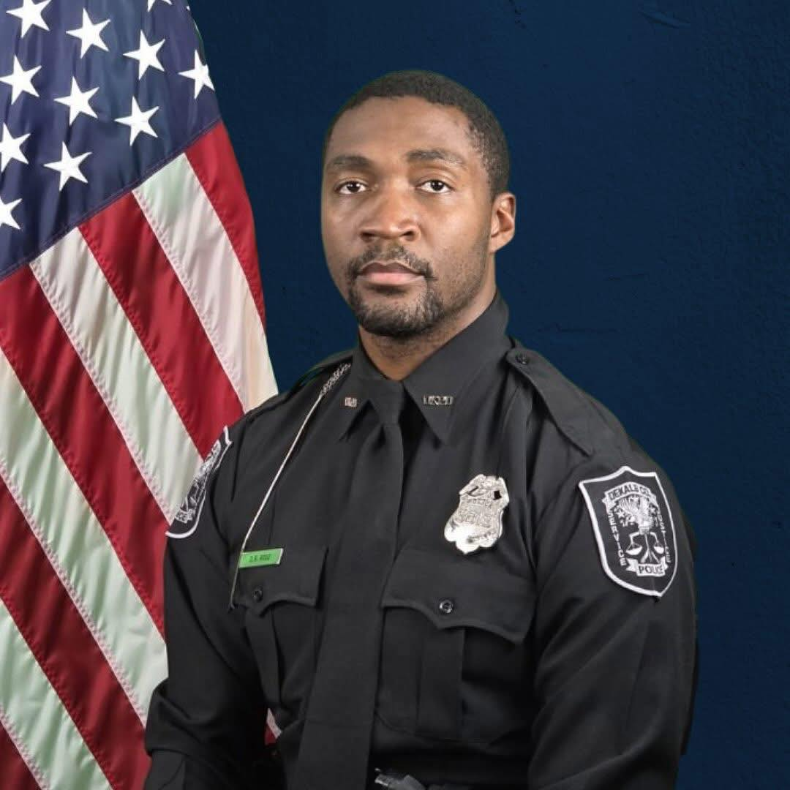
Update: On the morning of 05/29/2025, the subject, Jason Garrett turned himself in at the Towns County Sheriffs Office.
The Towns County Sheriff's Office Drug Investigators conducted a month long investigation into an individual at a residence on Bugscuffle Rd.
On 05/21/2025, investigators obtained a search warrant for the residence. During the execution of the search an amount of meth which field tested positive was confiscated along with multiple types of pills. During the execution of the search of the residence, the 2 individuals that were the target of the drug investigation were not at the residence at the time.
Laurel Taylor Lambert, 40, of Hayesville NC, was arrested on 05/27/2025 on the warrants issued on 05/21/2025 and charged with:
• Felony, Possession of Methamphetamine
On 05/21/2025, arrest warrants were issued on Jason Levon Garrett, 51, of Hiawassee, for the following charges:
• Felony, Possession of Methamphetamine
• Felony, Possession of a controlled substance with intent to distribute
• Felony, Possession of a controlled substance X3
• Misdemeanor, Possession and Use of Drug Related Objects
Garrett is still at large on active warrants. Anyone with information of the subjects whereabouts should contact the Towns County Sheriff’s Office or call 911.
Sheriff Ken Henderson stated during the investigation, information was revealed that the suspect, Garrett, had been dealing drugs from his residence for at least 3 months. Sheriff Henderson commends the drug investigators and uniform patrol deputies for their hard work on a month long investigation into individuals who were selling drugs in our community. Our war on drugs continues.
**All subjects are presumed innocent until proven guilty in a court of law**

Pack the Patrol Unit School Supply Drive a Success!

Our Back To School Supplies drive was a huge success — and it’s all thanks to YOU!
Your generosity has filled backpacks, classrooms, and hearts across our community. From pencils and paper to backpacks and binders, every single donation will make a difference for a local student this school year.

Sheriff Henderson would like to personally thank each and every one who stopped by to give — together, we’re making sure every child starts the year ready to learn.
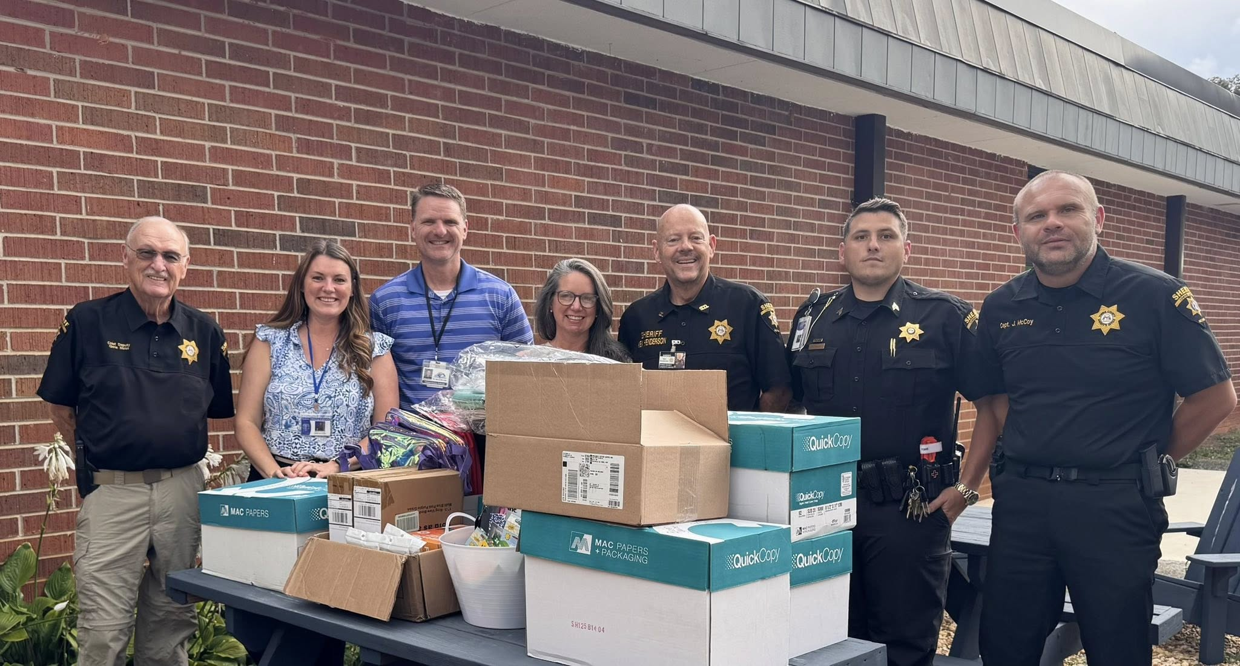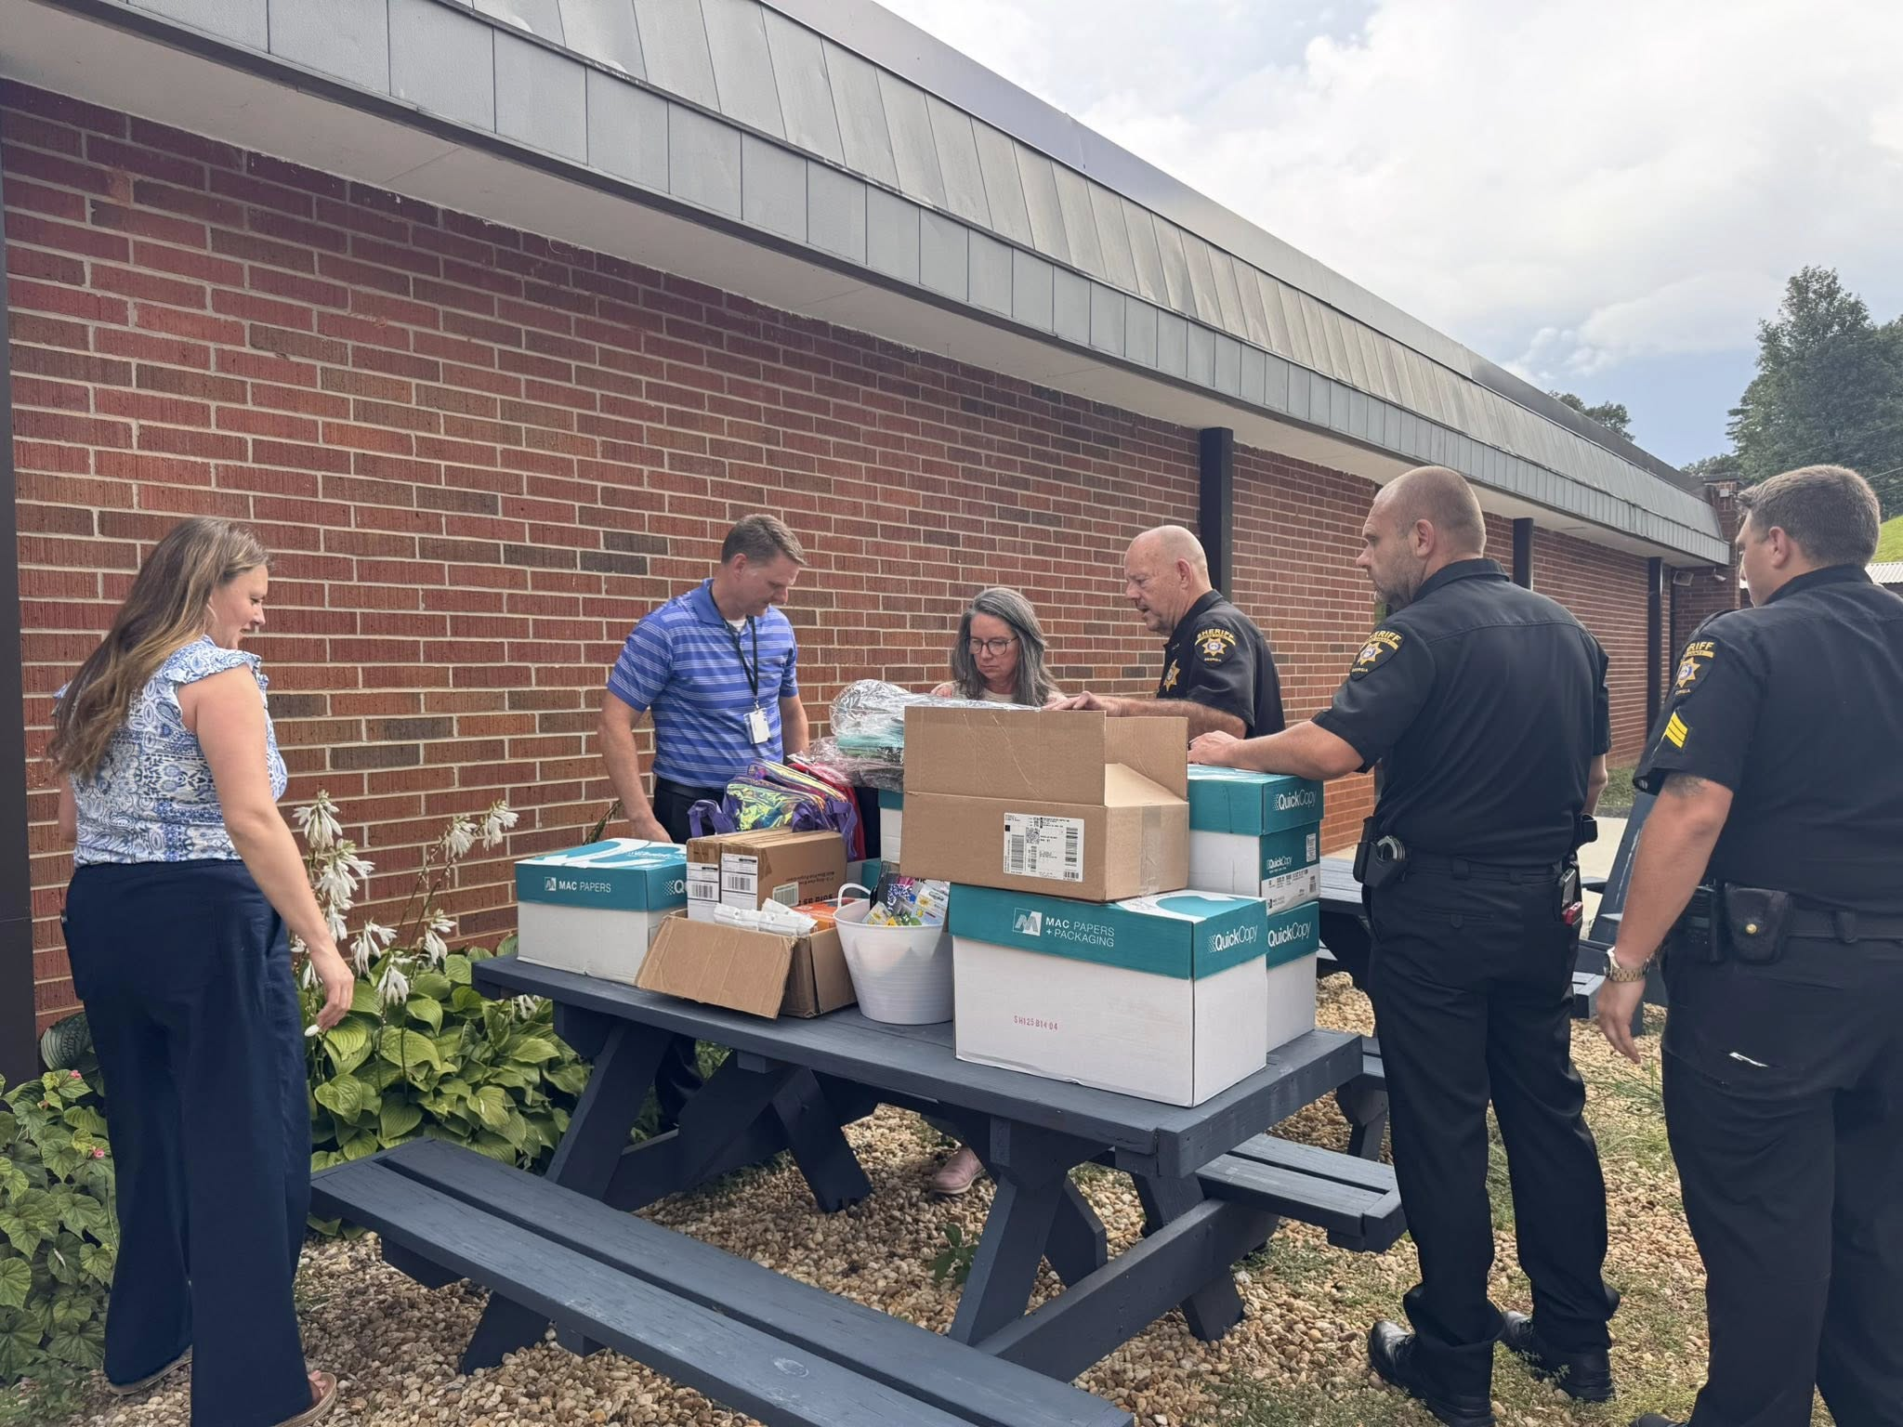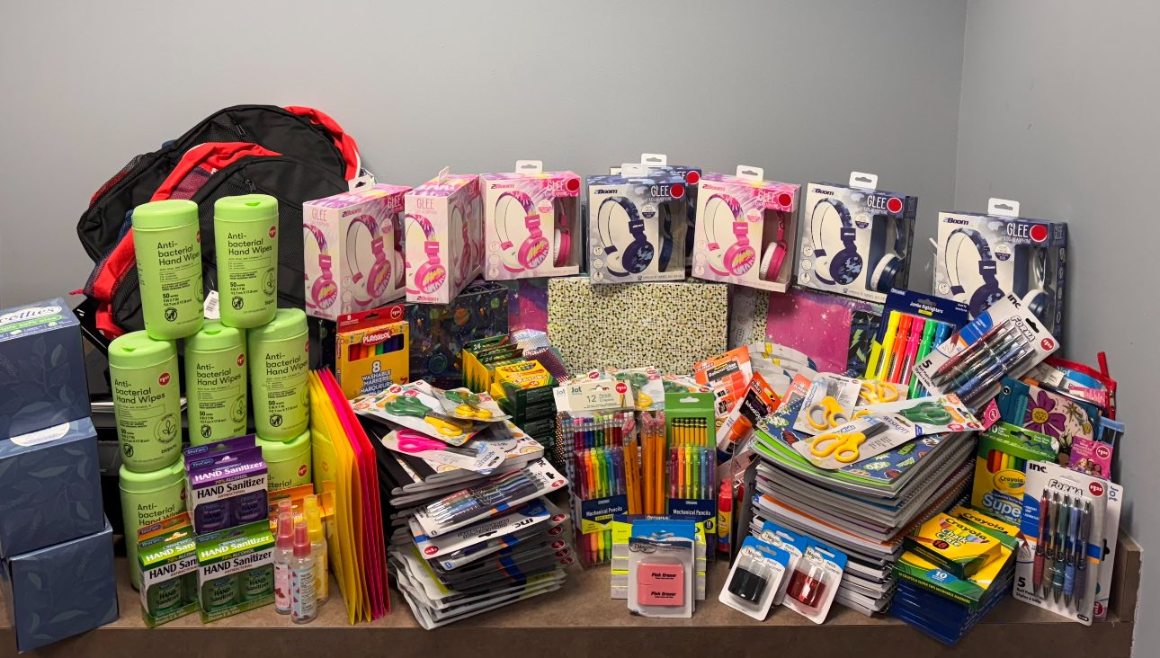

Update: On the morning of 05/29/2025, the subject, Jason Garrett turned himself in at the Towns County Sheriffs Office.
The Towns County Sheriff's Office Drug Investigators conducted a month long investigation into an individual at a residence on Bugscuffle Rd.
On 05/21/2025, investigators obtained a search warrant for the residence. During the execution of the search an amount of meth which field tested positive was confiscated along with multiple types of pills. During the execution of the search of the residence, the 2 individuals that were the target of the drug investigation were not at the residence at the time.
Laurel Taylor Lambert, 40, of Hayesville NC, was arrested on 05/27/2025 on the warrants issued on 05/21/2025 and charged with:
• Felony, Possession of Methamphetamine
On 05/21/2025, arrest warrants were issued on Jason Levon Garrett, 51, of Hiawassee, for the following charges:
• Felony, Possession of Methamphetamine
• Felony, Possession of a controlled substance with intent to distribute
• Felony, Possession of a controlled substance X3
• Misdemeanor, Possession and Use of Drug Related Objects
Garrett is still at large on active warrants. Anyone with information of the subjects whereabouts should contact the Towns County Sheriff’s Office or call 911.
Sheriff Ken Henderson stated during the investigation, information was revealed that the suspect, Garrett, had been dealing drugs from his residence for at least 3 months. Sheriff Henderson commends the drug investigators and uniform patrol deputies for their hard work on a month long investigation into individuals who were selling drugs in our community. Our war on drugs continues.
**All subjects are presumed innocent until proven guilty in a court of law**

Georgia Mountain Fair Parade Shenanigans

What a great day we had yesterday supporting the 75th Anniversary of the Georgia Mountain Fairgrounds
It was such an amazing turnout. Congratulations to Hilda Thomason and her parade committee on a job well done.
See If you can spot some of your favorite people! We had a great time being part of the fun!
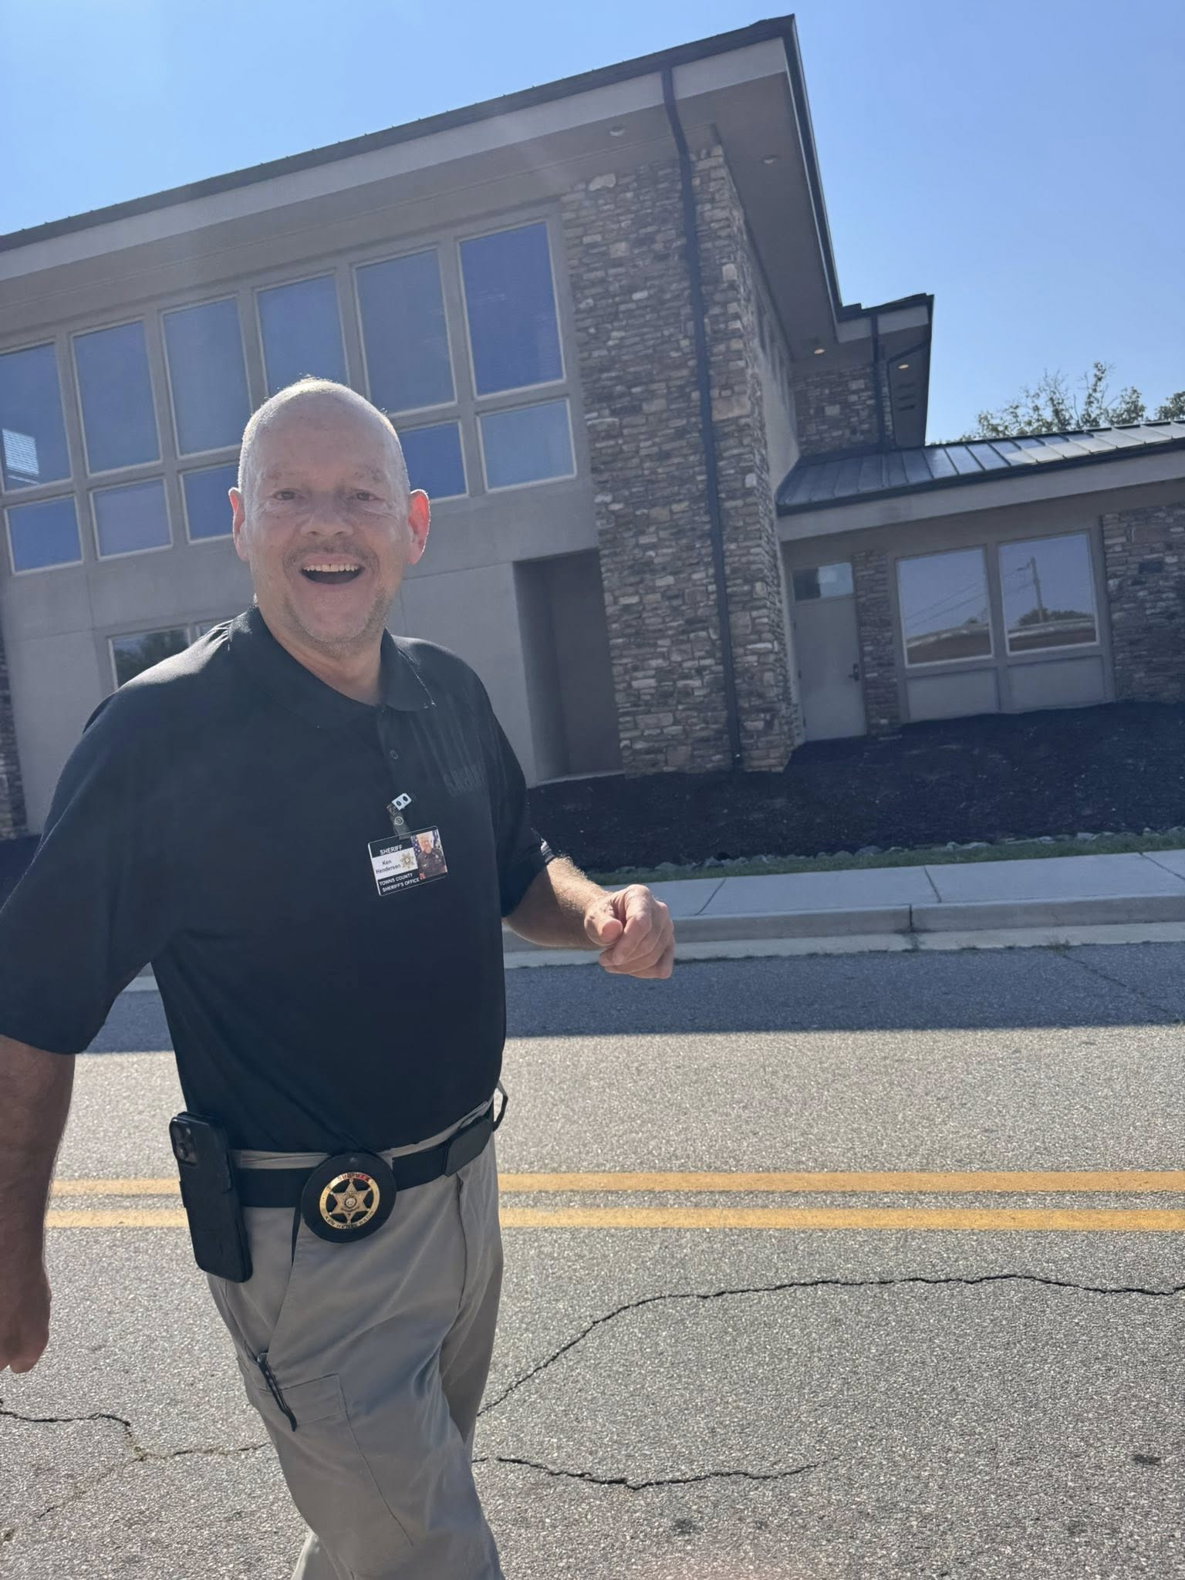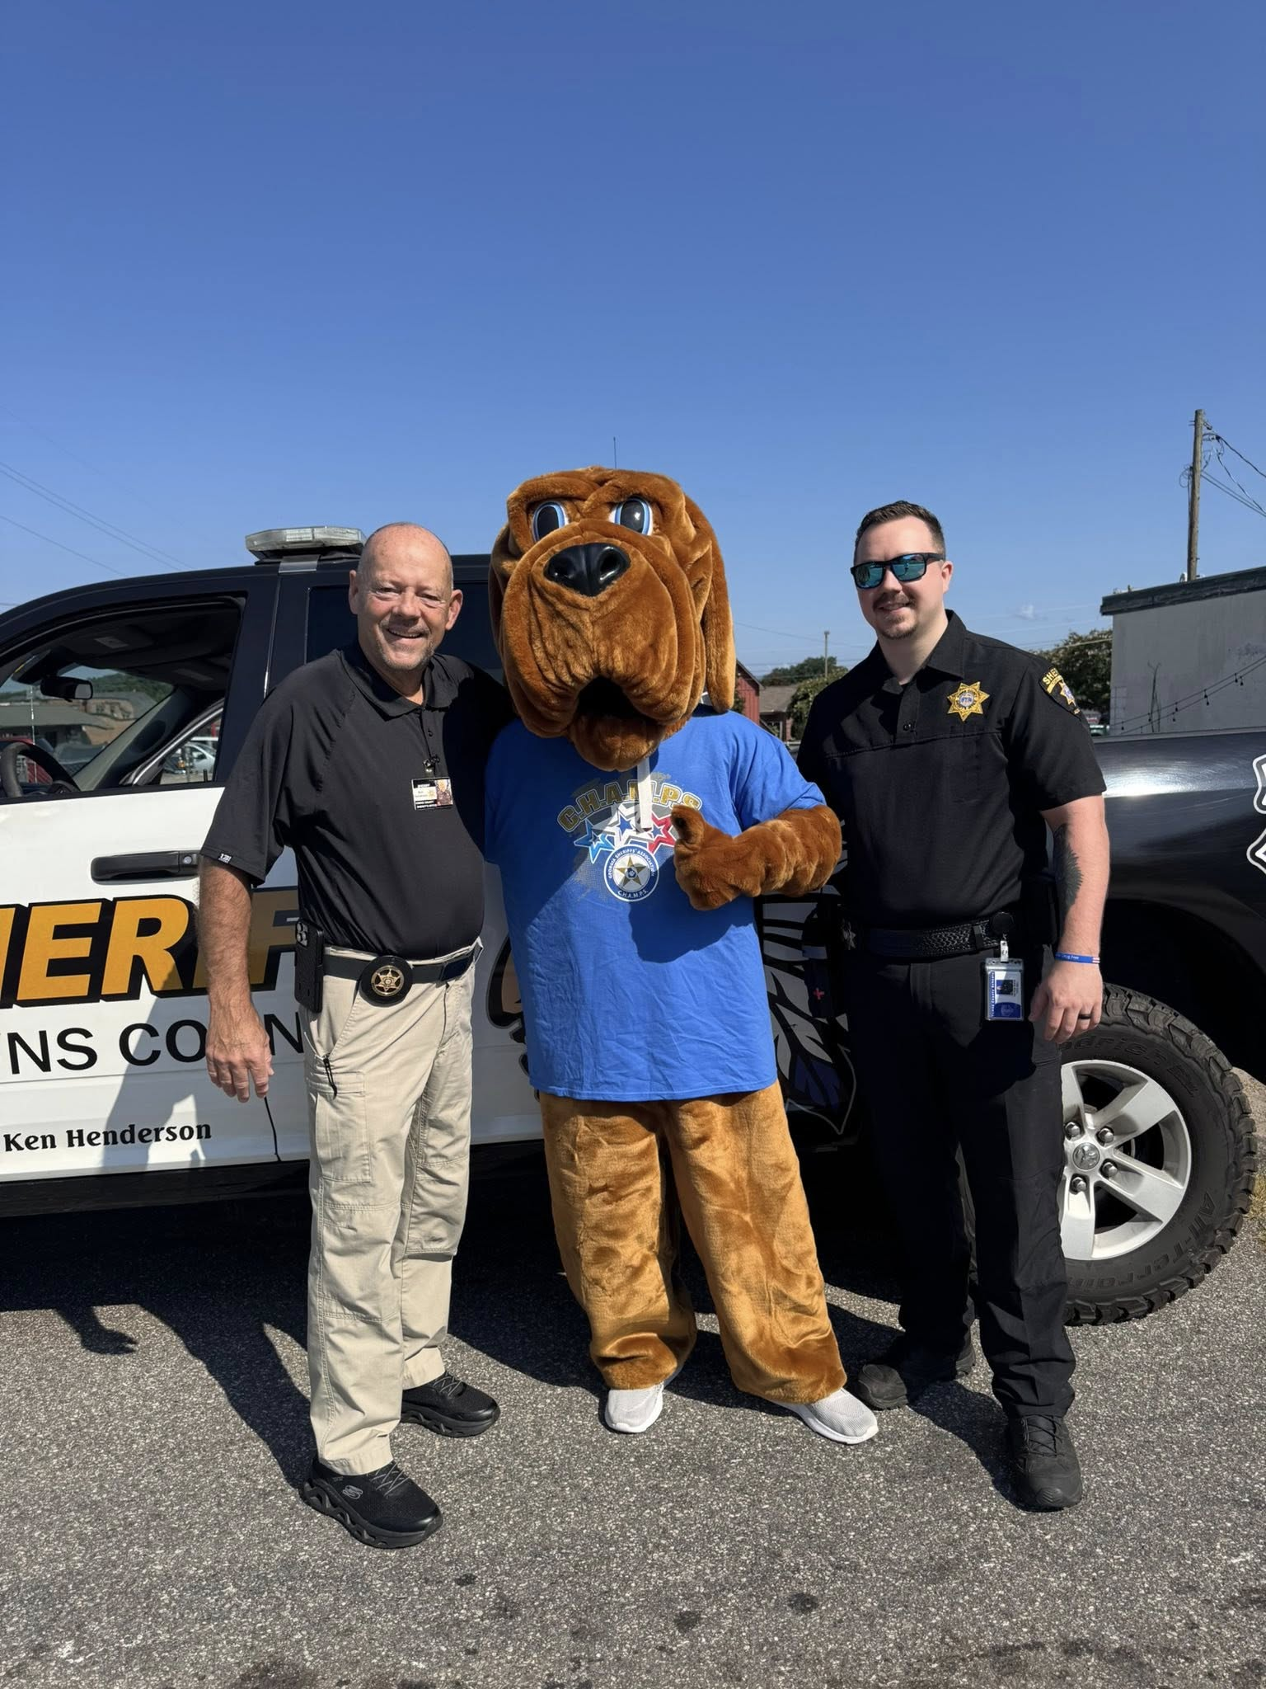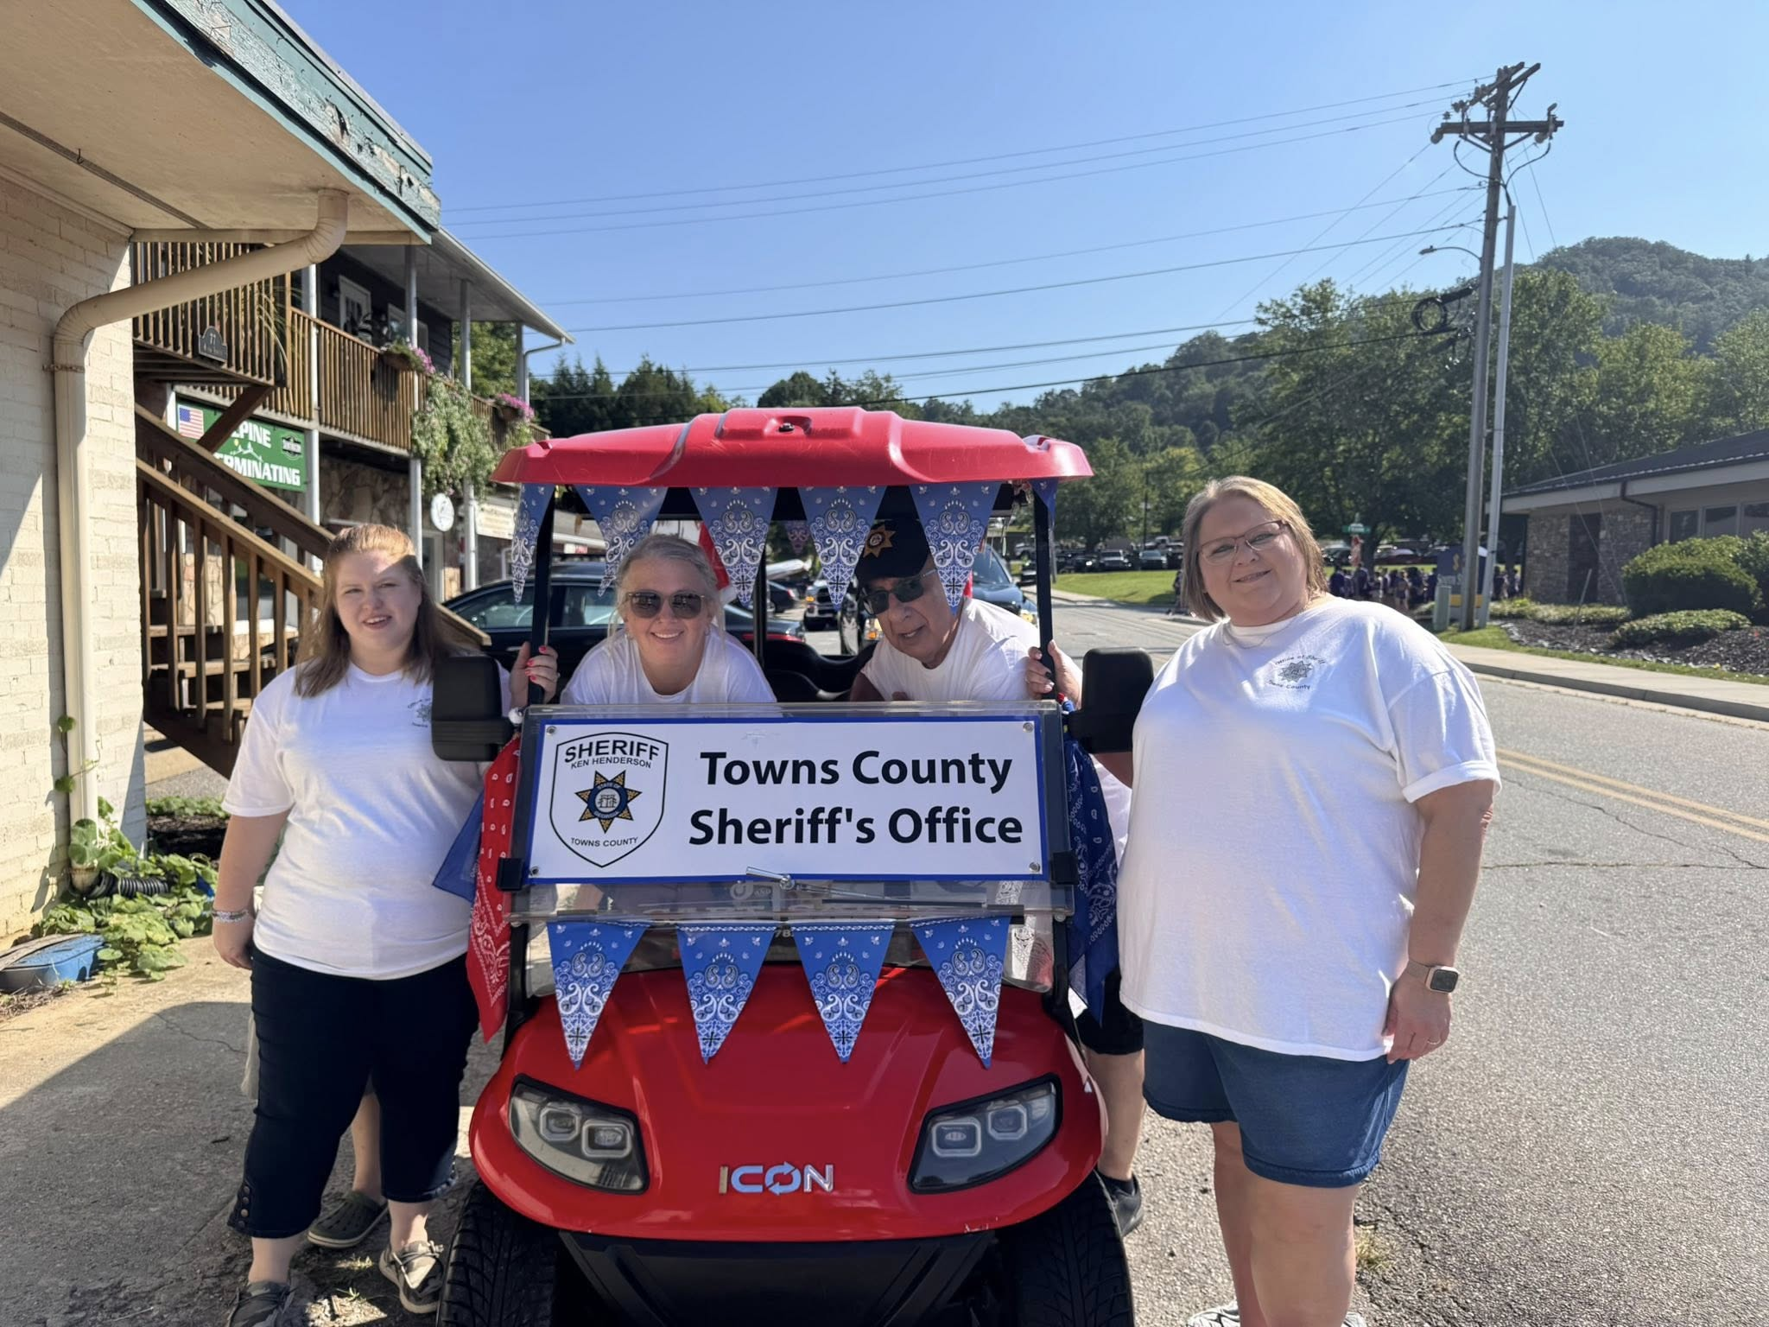
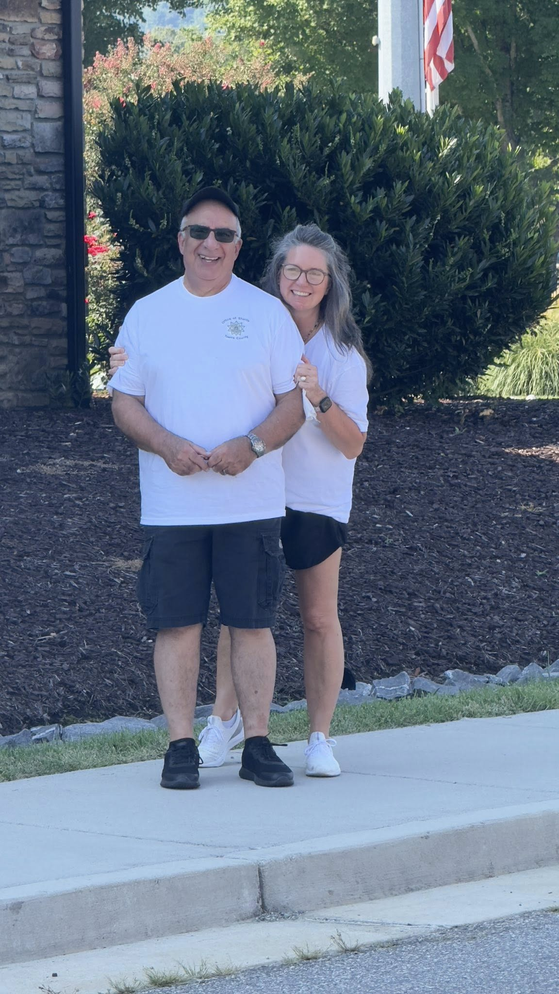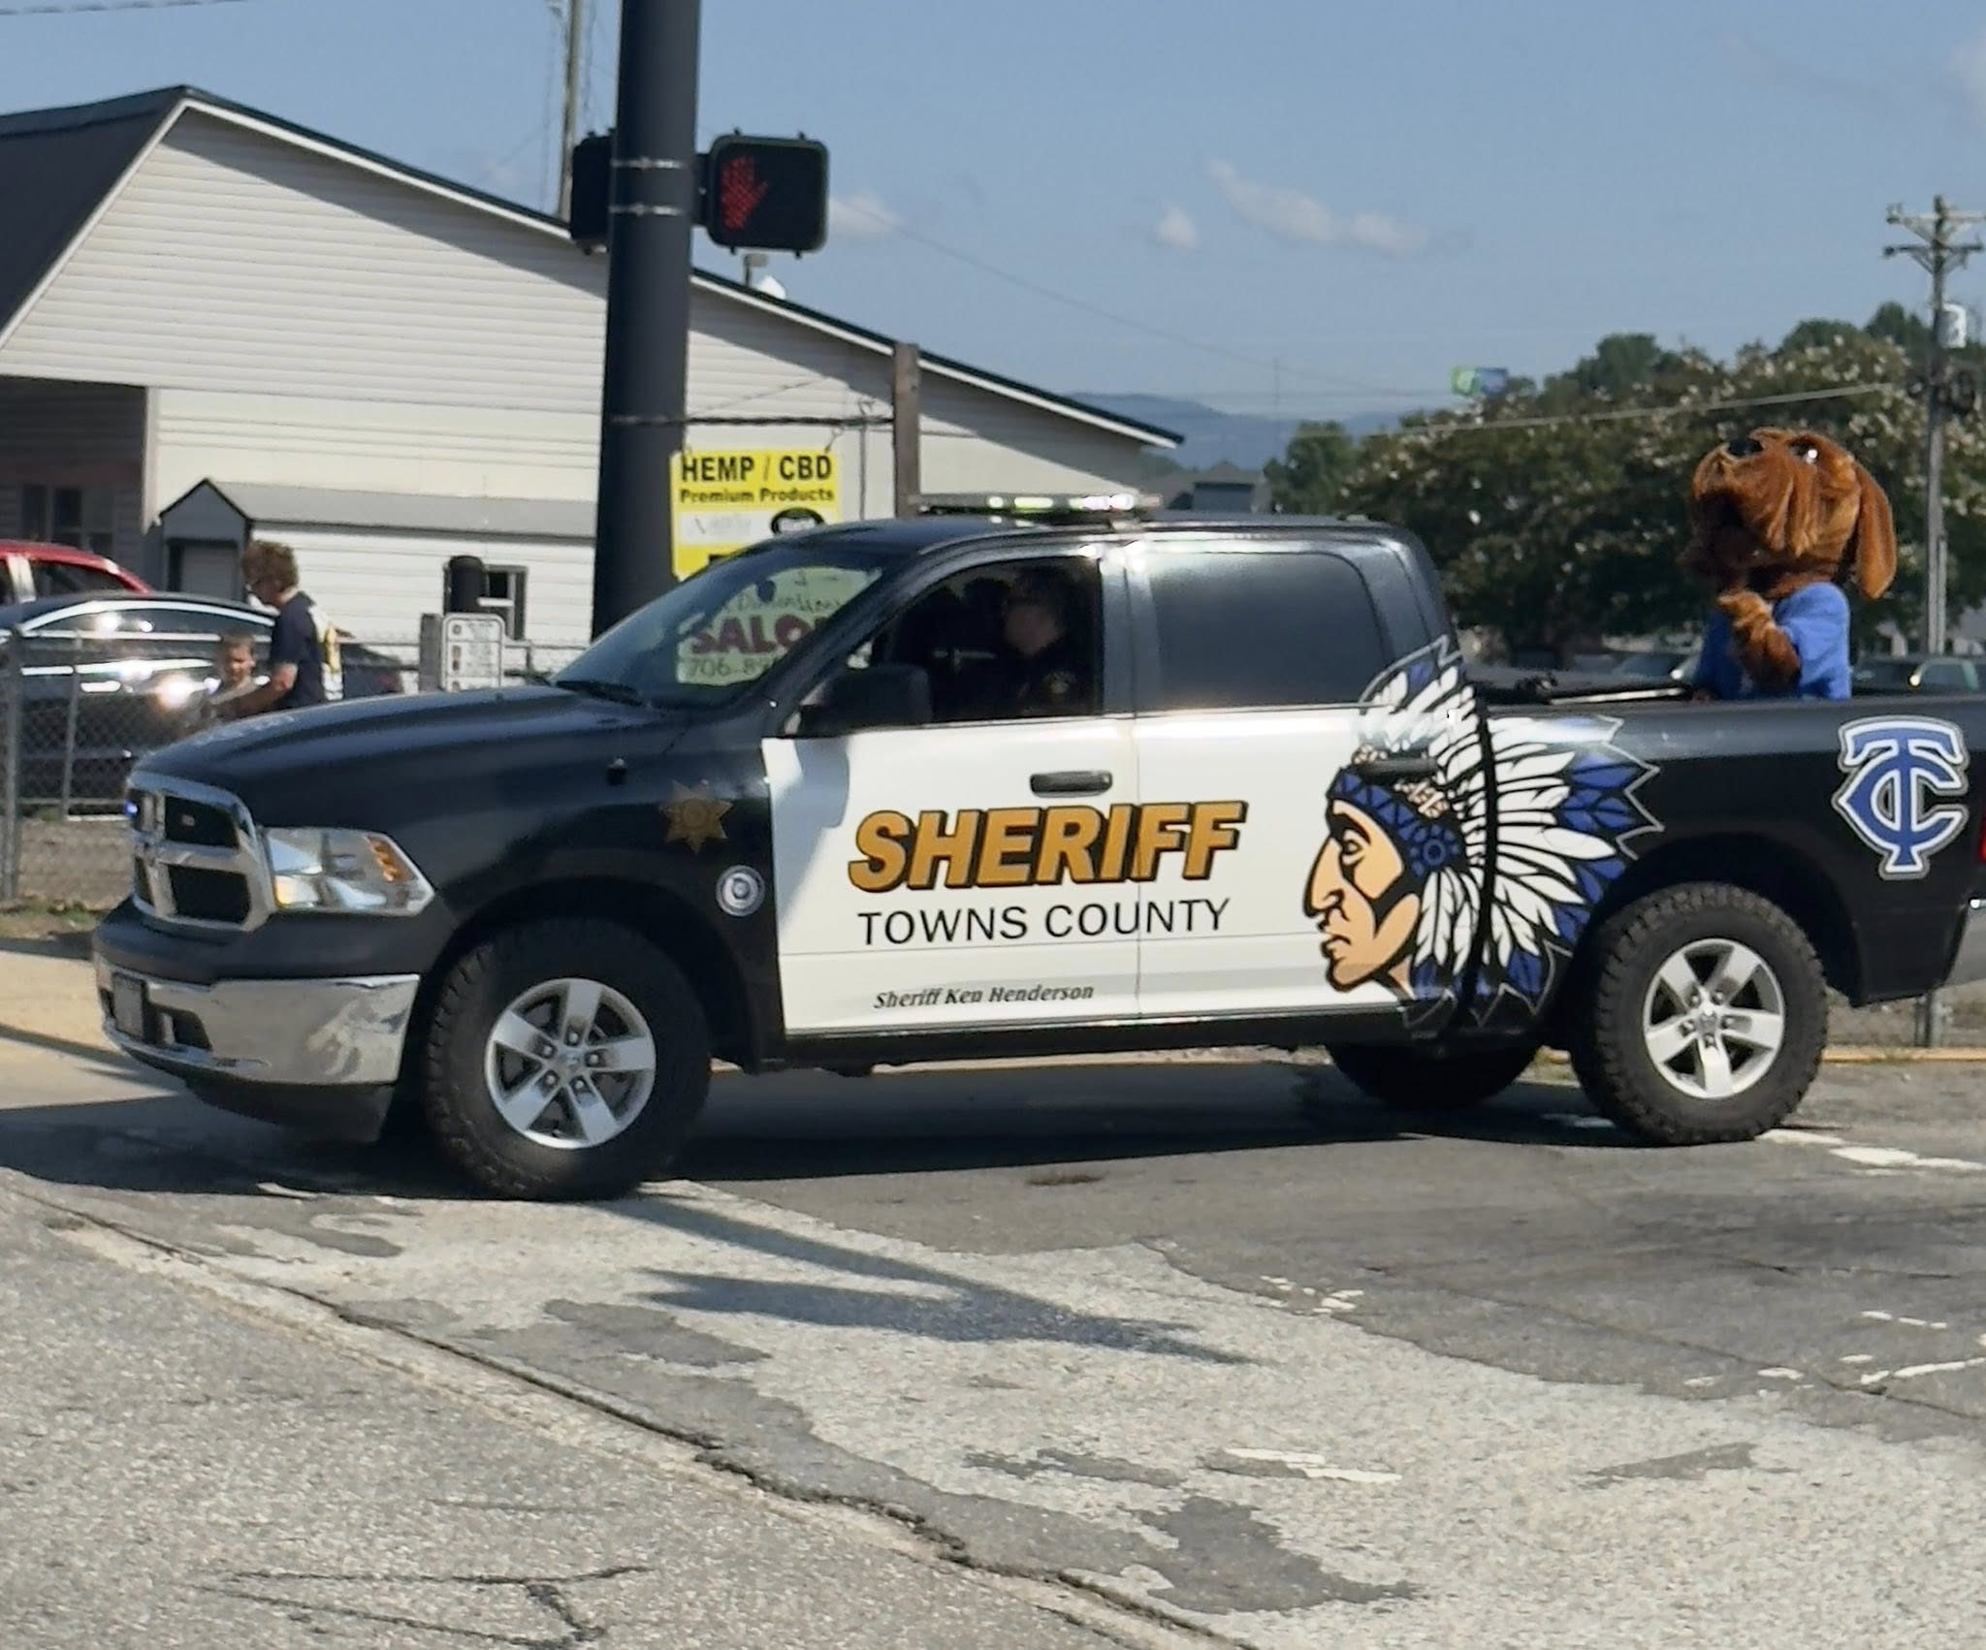
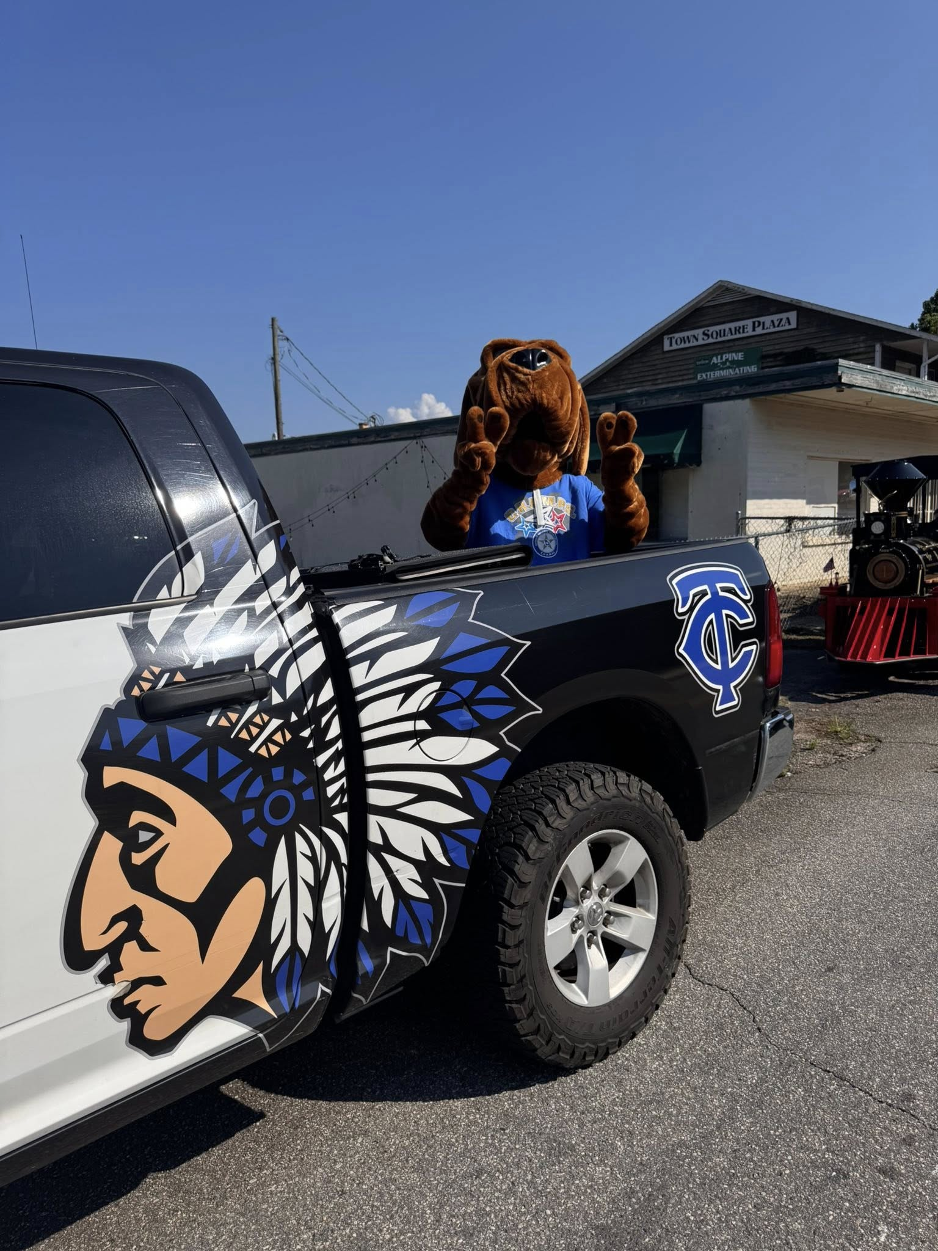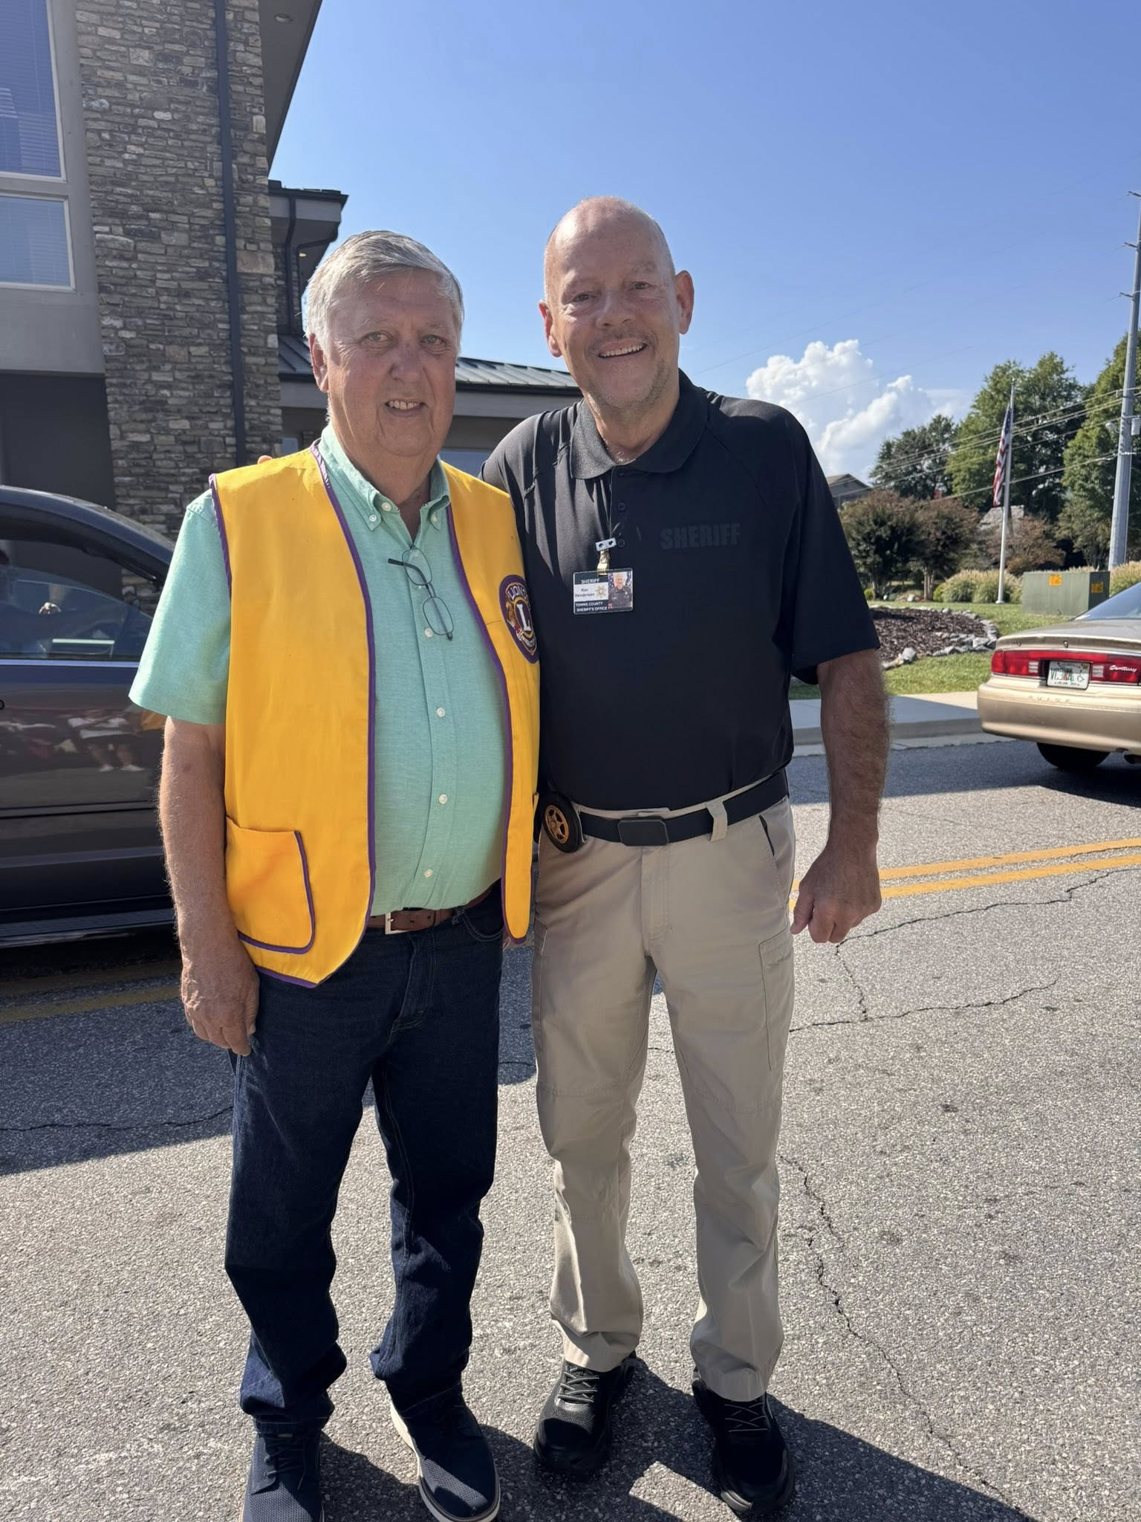
Update: On the morning of 05/29/2025, the subject, Jason Garrett turned himself in at the Towns County Sheriffs Office.
The Towns County Sheriff's Office Drug Investigators conducted a month long investigation into an individual at a residence on Bugscuffle Rd.
On 05/21/2025, investigators obtained a search warrant for the residence. During the execution of the search an amount of meth which field tested positive was confiscated along with multiple types of pills. During the execution of the search of the residence, the 2 individuals that were the target of the drug investigation were not at the residence at the time.
Laurel Taylor Lambert, 40, of Hayesville NC, was arrested on 05/27/2025 on the warrants issued on 05/21/2025 and charged with:
• Felony, Possession of Methamphetamine
On 05/21/2025, arrest warrants were issued on Jason Levon Garrett, 51, of Hiawassee, for the following charges:
• Felony, Possession of Methamphetamine
• Felony, Possession of a controlled substance with intent to distribute
• Felony, Possession of a controlled substance X3
• Misdemeanor, Possession and Use of Drug Related Objects
Garrett is still at large on active warrants. Anyone with information of the subjects whereabouts should contact the Towns County Sheriff’s Office or call 911.
Sheriff Ken Henderson stated during the investigation, information was revealed that the suspect, Garrett, had been dealing drugs from his residence for at least 3 months. Sheriff Henderson commends the drug investigators and uniform patrol deputies for their hard work on a month long investigation into individuals who were selling drugs in our community. Our war on drugs continues.
**All subjects are presumed innocent until proven guilty in a court of law**

Towns County GOP Meeting

Sheriff Ken Henderson is always incredibly humbled and honored to attend the Town’s County GOP meetings and yesterday afternoon was no different.
Sheriff Henderson would like to thank the GOP for their hard work and dedication to the citizens of Towns County.

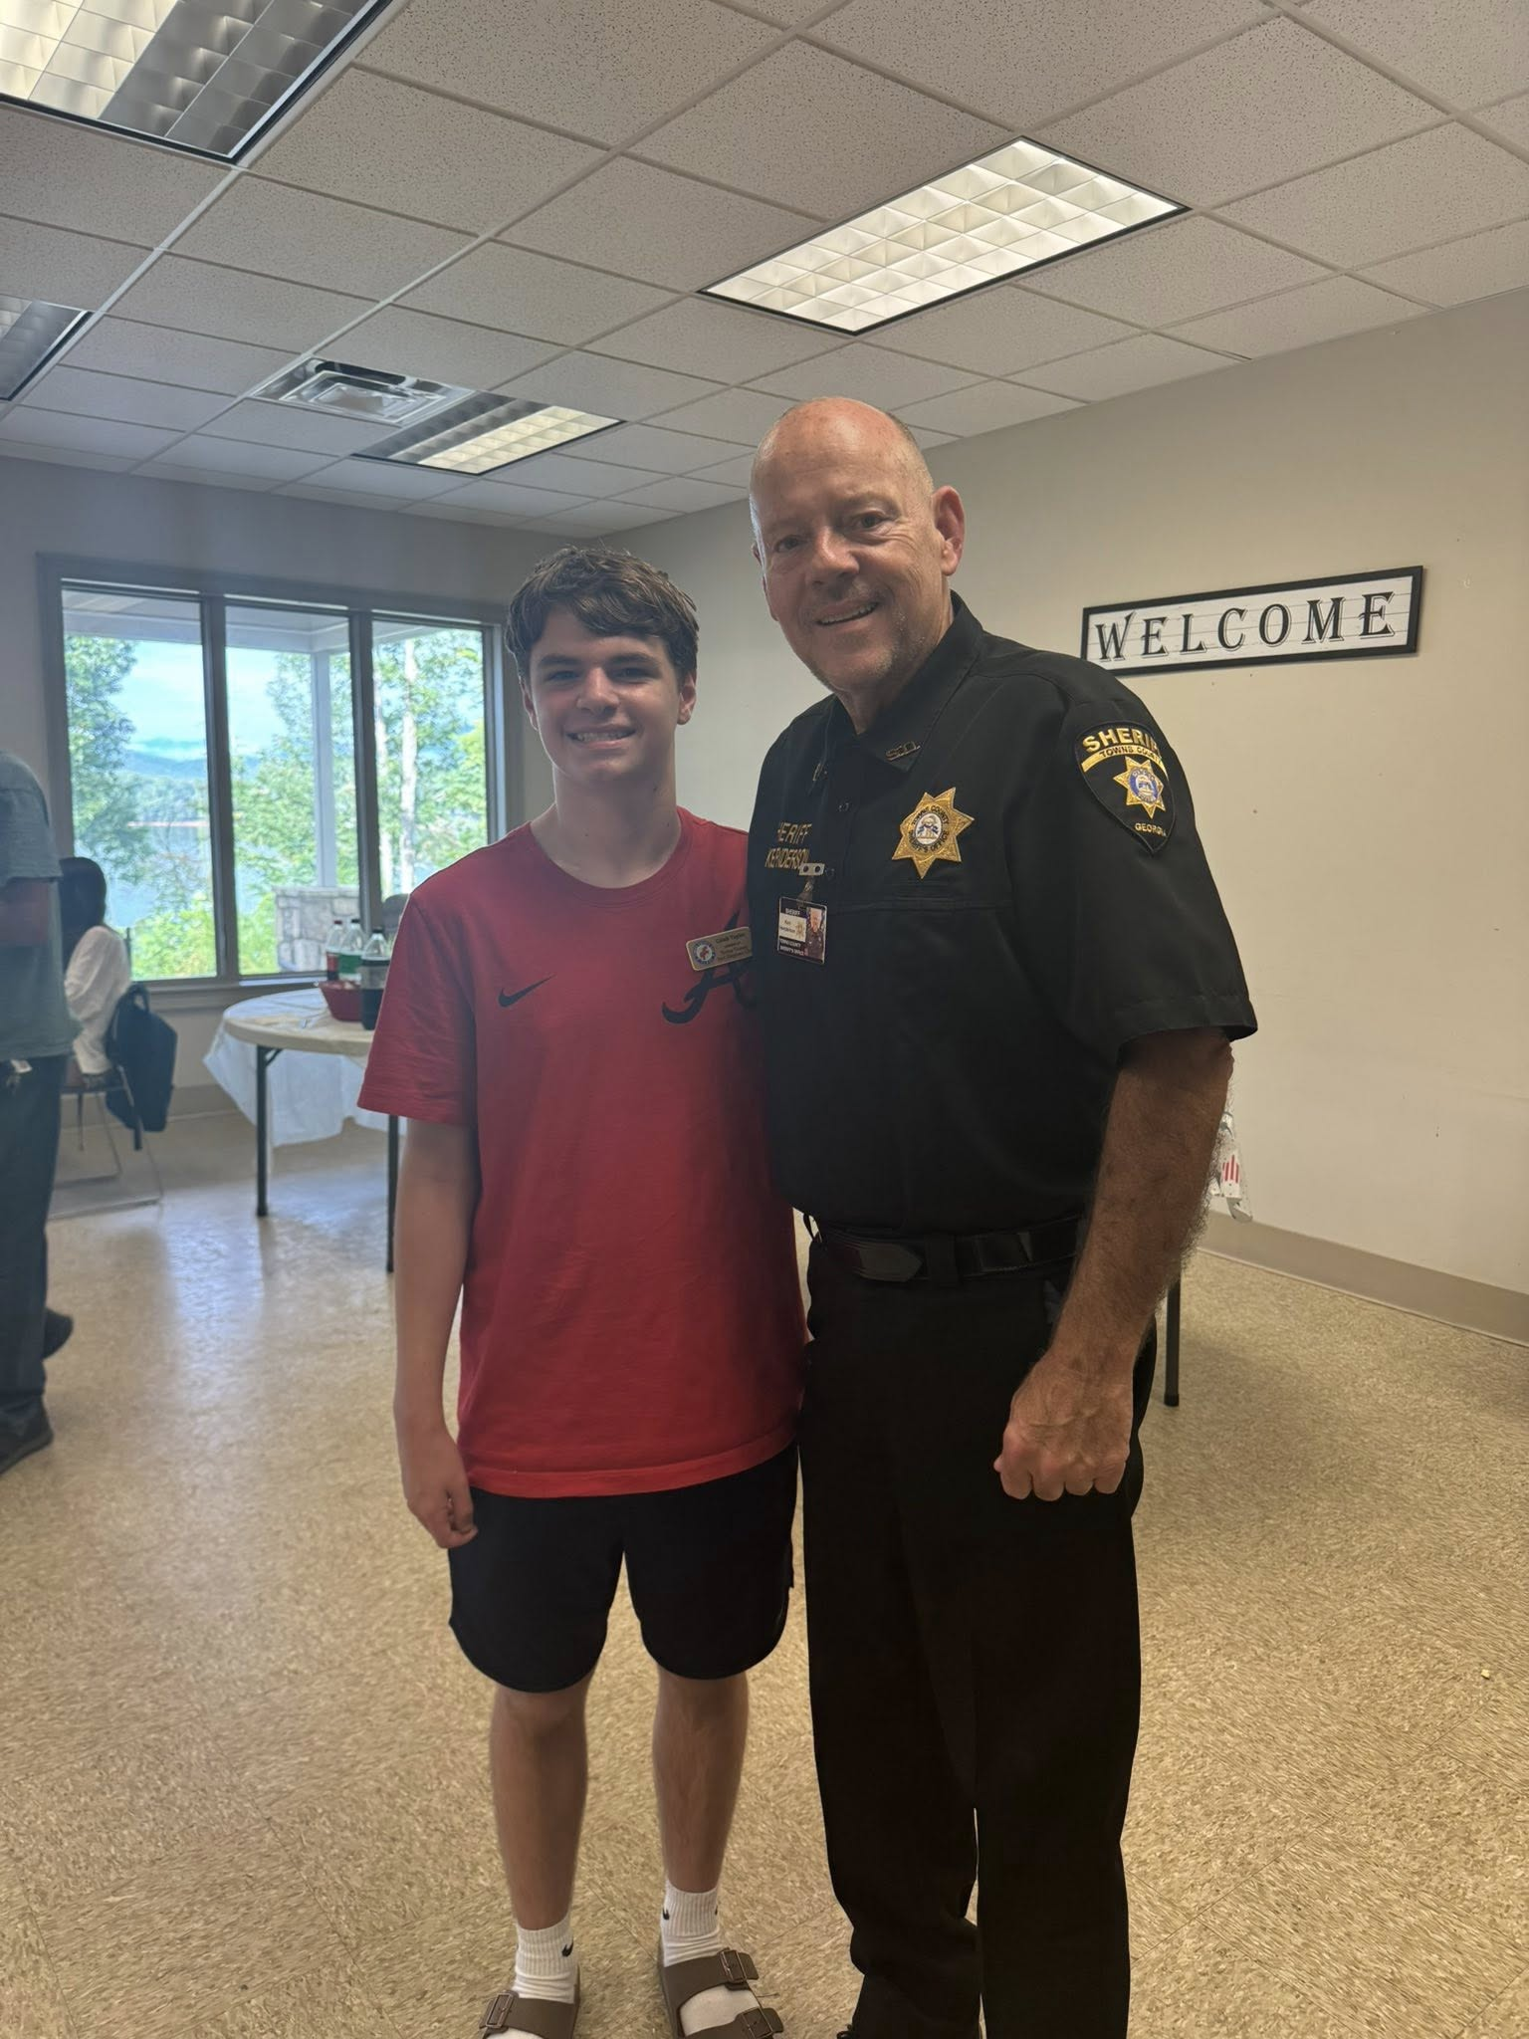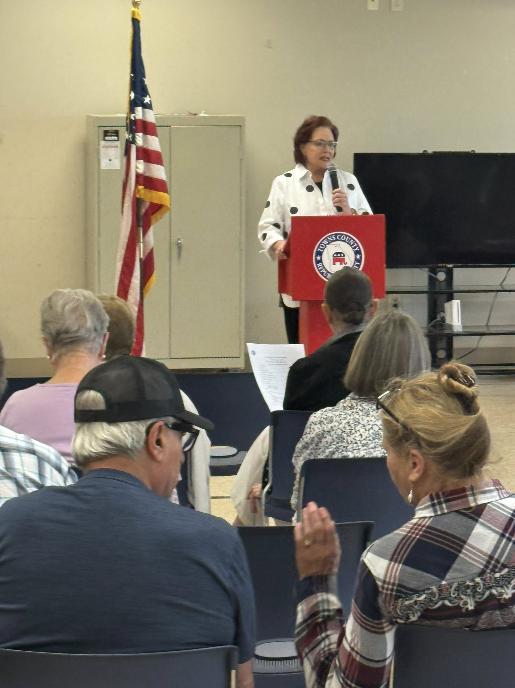
Update: On the morning of 05/29/2025, the subject, Jason Garrett turned himself in at the Towns County Sheriffs Office.
The Towns County Sheriff's Office Drug Investigators conducted a month long investigation into an individual at a residence on Bugscuffle Rd.
On 05/21/2025, investigators obtained a search warrant for the residence. During the execution of the search an amount of meth which field tested positive was confiscated along with multiple types of pills. During the execution of the search of the residence, the 2 individuals that were the target of the drug investigation were not at the residence at the time.
Laurel Taylor Lambert, 40, of Hayesville NC, was arrested on 05/27/2025 on the warrants issued on 05/21/2025 and charged with:
• Felony, Possession of Methamphetamine
On 05/21/2025, arrest warrants were issued on Jason Levon Garrett, 51, of Hiawassee, for the following charges:
• Felony, Possession of Methamphetamine
• Felony, Possession of a controlled substance with intent to distribute
• Felony, Possession of a controlled substance X3
• Misdemeanor, Possession and Use of Drug Related Objects
Garrett is still at large on active warrants. Anyone with information of the subjects whereabouts should contact the Towns County Sheriff’s Office or call 911.
Sheriff Ken Henderson stated during the investigation, information was revealed that the suspect, Garrett, had been dealing drugs from his residence for at least 3 months. Sheriff Henderson commends the drug investigators and uniform patrol deputies for their hard work on a month long investigation into individuals who were selling drugs in our community. Our war on drugs continues.
**All subjects are presumed innocent until proven guilty in a court of law**

Sheriff Hosts Georgia Governor’s Office Highway Safety Meeting

Towns County Sheriff Ken Henderson proudly hosted the Georgia Governor’s Office of Highway Safety meeting last night and couldn't have been more pleased at the turnout.
Officers from Towns, Dawson and Union County, McCaysville, Blairsville and Hiawassee Police Departments and the Georgia State Patrol were all in attendance.
Afterwards a road safety check was conducted in the area of Hwy. 76 and Hwy. 288. Sheriff Henderson will continue to do these safety checks as they are a productive approach in keeping our roads and communities safe.
Sheriff Henderson as always is committed to working with surrounding agencies to improve comradery and cement relationships with agency's closest to us and would like to thank all who attended the training and networking that the Georgia Governor’s ‘s Office of Highway Safety provides to the State of Georgia and the citizens of Towns County.
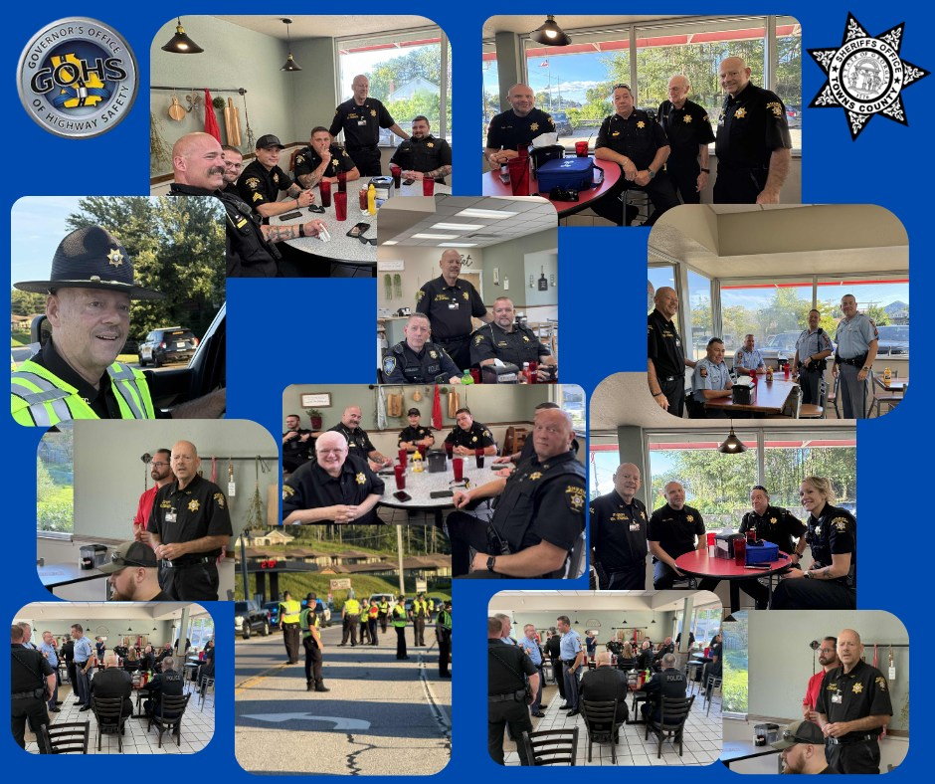
SCAM ALERT!! 
Are you receiving repeated calls or messages from "Olivia" regarding your current tax situation??
Here is some information on one of the latest scam calls out there.
The "Olivia regarding your current tax situation" message is a common scam; the IRS does not initiate contact via phone calls or emails, nor do they demand immediate payment or threat of arrest or deportation. Ignore these calls, do not reply or click on any links, and report the scam to the Federal Trade Commission at FTC.gov/impostors and the IRS at phishing@irs.gov.
Why this is a scam?
- Method of Contact
The IRS’s first contact with you is always a letter in the mail. They do not call, email, or text you about tax debt.
2. Threats and Pressure
Scammers often play on fears, threatening arrest, deportation, or legal action to pressure you into immediate payment. The IRS does not operate this way.
3. Demands for Payment Methods
Scammers may insist you pay with a prepaid debit card, wire transfer, or cashier’s check, which are not accepted by the IRS for tax payments.
4. Offering to take care of your “tax situation: for a fee.
5. Fake Caller ID
Scammers can “rig” caller ID to make their call appear official.
6. “Press 2 or 9 to be removed” tactics
This is a classic red flag used by scammers to confirm your number is active.
What to do:
- Do not reply
Engaging with the message, whether by phone or by email, will confirm your number is active and may lead to more scam attempts.
2. Do not click links:
Never click on links in suspicious emails or texts, as they can lead to harmful websites.
3. Block the number:
Block the numbers that call you, but be aware that scammers use many different numbers.
4. Report the scam:
-To the IRS @irs.gov.
-To FTC.gov/impostors.
If you are unsure about your tax situation contact the IRS directly by using the official phone numbers found on IRS.gov. Do not use any phone numbers provided by the scammer.

Update: On the morning of 05/29/2025, the subject, Jason Garrett turned himself in at the Towns County Sheriffs Office.
The Towns County Sheriff's Office Drug Investigators conducted a month long investigation into an individual at a residence on Bugscuffle Rd.
On 05/21/2025, investigators obtained a search warrant for the residence. During the execution of the search an amount of meth which field tested positive was confiscated along with multiple types of pills. During the execution of the search of the residence, the 2 individuals that were the target of the drug investigation were not at the residence at the time.
Laurel Taylor Lambert, 40, of Hayesville NC, was arrested on 05/27/2025 on the warrants issued on 05/21/2025 and charged with:
• Felony, Possession of Methamphetamine
On 05/21/2025, arrest warrants were issued on Jason Levon Garrett, 51, of Hiawassee, for the following charges:
• Felony, Possession of Methamphetamine
• Felony, Possession of a controlled substance with intent to distribute
• Felony, Possession of a controlled substance X3
• Misdemeanor, Possession and Use of Drug Related Objects
Garrett is still at large on active warrants. Anyone with information of the subjects whereabouts should contact the Towns County Sheriff’s Office or call 911.
Sheriff Ken Henderson stated during the investigation, information was revealed that the suspect, Garrett, had been dealing drugs from his residence for at least 3 months. Sheriff Henderson commends the drug investigators and uniform patrol deputies for their hard work on a month long investigation into individuals who were selling drugs in our community. Our war on drugs continues.
**All subjects are presumed innocent until proven guilty in a court of law**

SHERIFF APPRECIATES HIAWASSEE FAMILY RESTAURANT

Sheriff Ken Henderson would like to thank Julie Ashe and her staff at Hiawassee Family Restaurant for allowing us to have our Governor's Office of Highway Safety meeting at her restaurant last night.
The food was absolutely amazing, and Julie went above and beyond to personally greet everyone in attendance.
Thank you very much Julie, we will definitely be coming back again!
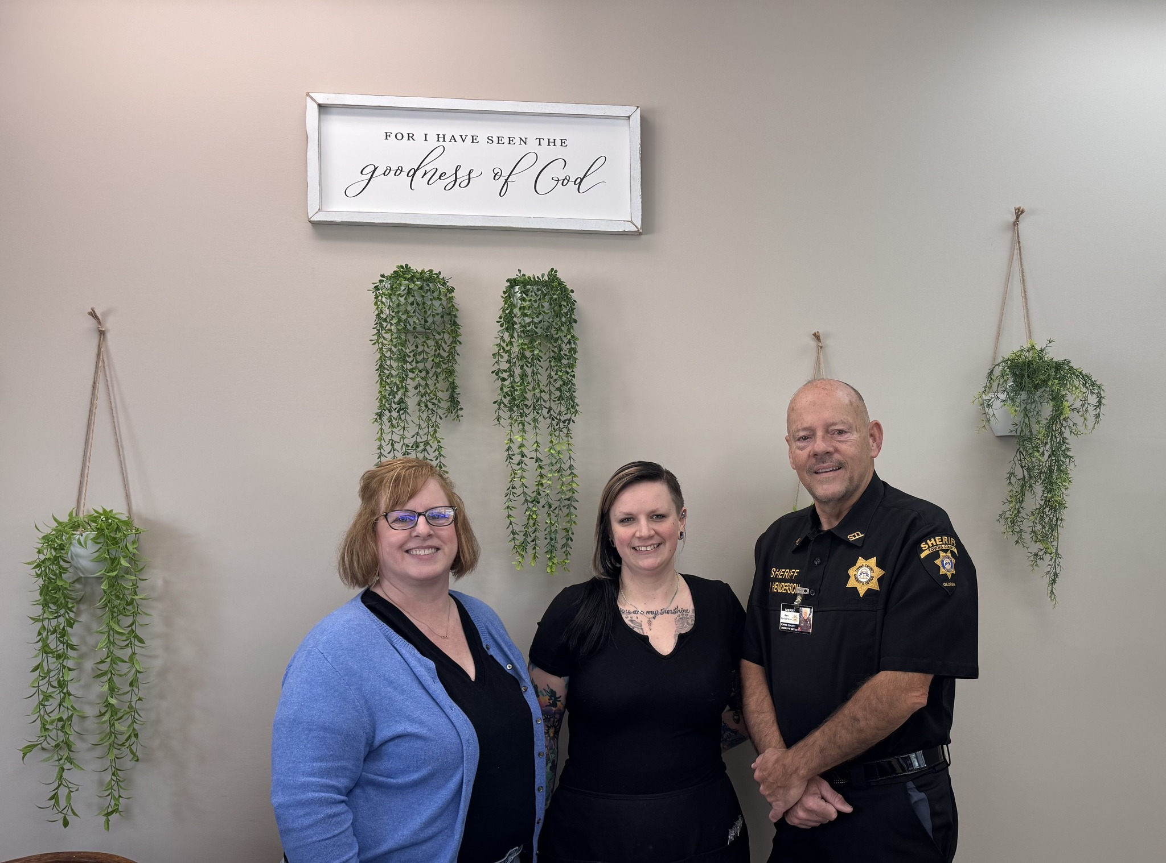
[Grab your reader’s attention with a great quote from the document or use this space to emphasize a key point. To place this text box anywhere on the page, just drag it.]

AUGUST STATISTICS
 | Aug
August Arrests. . . . . . . . . . . . . . . . . . . . . . . . . . . . . . . . . . | 22
2025 Arrests . . . . . . . . . . . . . . . . . . . . . . . . . . . . . . . . . . . | 169
July Calls for Service. . . . . . . . . . . . . . . . . . . . . . . . . . . . . | 424
Traffic Crimes. . . . . . . . . . . . . . . . . . . . . . . . . . . . . . . . .
Personal Crimes. . . . . . . . . . . . . . . . . . . . . . . . . . . . . . . . . . . . . . . | 0
*Aggravated Assault . . . . . . . . . . . . . . . . . . . . . . . . . . . | 0
*Aggravated Assault Against Law Enforcement. . . . . . . | 0
*Aggravated Battery . . . . . . . . . . . . . . . . . . . . . . . . . . . | 0
*Aggravated Sexual Battery. . . . . . . . . . . . . . . . . . . . . . | 2
*Aggravated Sodomy. . . . . . . . . . . . . . . . . . . . . . . . . . . . | 1
*Aggravated Stalking. . . . . . . . . . . . . . . . . . . . . . . . . . . . . | 0
*Battery. . . . . . . . . . . . . . . . . . . . . . . . . . . . . . . . . . . . . . . | 0
*Battery Family Violence. . . . . . . . . . . . . . . . . . . . . . . . . . | 0
*Child Endangerment. . . . . . . . . . . . . . . . . . . . . . . . . . . . | 0
*Child Molestation. . . . . . . . . . . . . . . . . . . . . . . . . . . . . . . | 1
*Cruelty to Children. . . . . . . . . . . . . . . . . . . . . . . . . . . . . . | 0
*Disorderly Conduct. . . . . . . . . . . . . . . . . . . . . . . . . . . . . | 0
*Enticing a Child for indecent Purposes. . . . . . . . . . . . . . | 0
*False Imprisonment. . . . . . . . . . . . . . . . . . . . . . . . . . . . . | 0
*Harassing Phone Calls. . . . . . . . . . . . . . . . . . . . . . . . . . | 0
*Identity Theft Fraud Using/Possession ID | 0
*Obstruction or Hindering a 911 Call. . . . . . . . . . . . . . . . . | 0
*Obstruction of Law Enforcement. . . . . . . . . . . . . . . . . . . | 1
*Possession of Gun/Knife during a Crime | 2
Personal Crimes Continued
*Rape. . . . . . . . . . . . . . . . . . . . . . . . . . . . . . . . . . . . . . . . | 0
*Sexual Battery. . . . . . . . . . . . . . . . . . . . . . . . . . . . . . . . . | 1
*Simple Assault. . . . . . . . . . . . . . . . . . . . . . . . . . . . . . . . . | 0
*Simple Assault Family Violence. . . . . . . . . . . . . . . . . . . . | 1
*Simple Battery Against Law Enforcement. . . . . . . . . . . . | 0
*Simple Battery. . . . . . . . . . . . . . . . . . . . . . . . . . . . . . . . . | 0
*Statutory Rape. . . . . . . . . . . . . . . . . . . . . . . . . . . . . . . . . | 0
*Terroristic Threats/Acts. . . . . . . . . . . . . . . . . . . . . . . . . . | 0
*Violation of Family Violence Order . . . . . . . . . . . . . . . . . | 0
Property Crimes. . . . . . . . . . . . . . . . . . . . . . . . . . . . . . . . . . . . .. . . | 0
*Arson. . . . . . . . . . . . . . . . . . . . . . . . . . . . . . . . . . . . . . . . | 0
*Burglary. . . . . . . . . . . . . . . . . . . . . . . . . . . . . . . . . . . . . . | 0
*Computer Trespass. . . . . . . . . . . . . . . . . . . . . . . . . . . . . | 0
*Criminal Damage to Property. . . . . . . . . . . . . . . . . . . . . . | 0
*Criminal Trespass . . . . . . . . . . . . . . . . . . . . . . . . . . . . . . | 0
*Electronic Financial Transaction Theft. . . . . . . . . . . . . . . | 0
*Entering Vehicle w/Intent to Commit Theft. . . . . . . . . . . . | 0
*Loitering. . . . . . . . . . . . . . . . . . . . . . . . . . . . . . . . . . . . . . | 1
*Possession of Tools for Commission of Crime. . . . . . . . | 0
*Theft/Bringing Stolen Property into State. . . . . . . . . . . . . | 0
*Theft by Conversion. . . . . . . . . . . . . . . . . . . . . . . . . . . . . | 0
*Theft by Receiving Stolen Property. . . . . . . . . . . . . . . . . | 0
*Theft of Services. . . . . . . . . . . . . . . . . . . . . . . . . . . . . . . | 0
*Theft by Shoplifting. . . . . . . . . . . . . . . . . . . . . . . . . . . . . | 0
*Theft by Taking. . . . . . . . . . . . . . . . . . . . . . . . . . . . . . . . | 1
*Unlawful Ownership/Custody of Wildlife. . . . . . . . . . . . . | 0
*Violation of Bear Hunting Laws. . . . . . . . . . . . . . . . . . . . | 0
Substance Crime. . . . . . .. . . . . . . . . . . . . . . . . . . . . . . . . . . . . . . . | 0
*Driving Under the Influence Drugs/Alcohol. . . . . . . . . . . | 9
*Furnishing/Purch/Alcohol to Underage Person. . . . . . . . | 0
*Pedestrian Under the Influence. . . . . . . . . . . . . . . . . . . . | 0
*Possession of Cocaine | 0
*Possession of Drug Not in Original Container. . . . . . . . . | 0
*Possess/Use of Drug Related Objects. . . . . . . . . . . . . . . | 4
*Possess Marijuana Less than 1 oz | 2
*Possess/Sale/Distribution/Dangerous Drugs. . . . . . . . . . | 0
*Possess/Purch/Manuf/Dis/Sale of Marijuana. . . . . . . . . . | 1
*Possess/Manuf/Sell/Dist Syn/Cannavinoid/Marijuana. . . | 0
*Possess/Purch/Manuf/Dist/Methamphetamine. . . . . . . . | 4
*Posses/Manuf/Dist/ VGCS. . . . . . . . . . . . . . . . . . . . . . . . | 0
*Possess/Purch/Sale/Manuf/Dist of Controlled Substance. . . . . . | 3
*Public Drunkenness. . . . . . . . . . . . . . . . . . . . . . . . . . . . . | 0
*Trafficking in Cocaine/Meth/Illegal Drugs. . . . . . . . . . . . | 3
Towns County Sheriff’s Office
4070 State Highway 339
Young Harris, GA 30582
(706) 896-4444

www.townscountysheriff.org

https://www.facebook.com/TownsCountySheriffsOfficeGA

If you know someone who would like to receive the monthly newsletter, please have them contact Community Relations Coordinator Tabitha Sellers at (706) 896-4444 or tsellerstcso@townscountyga.com

